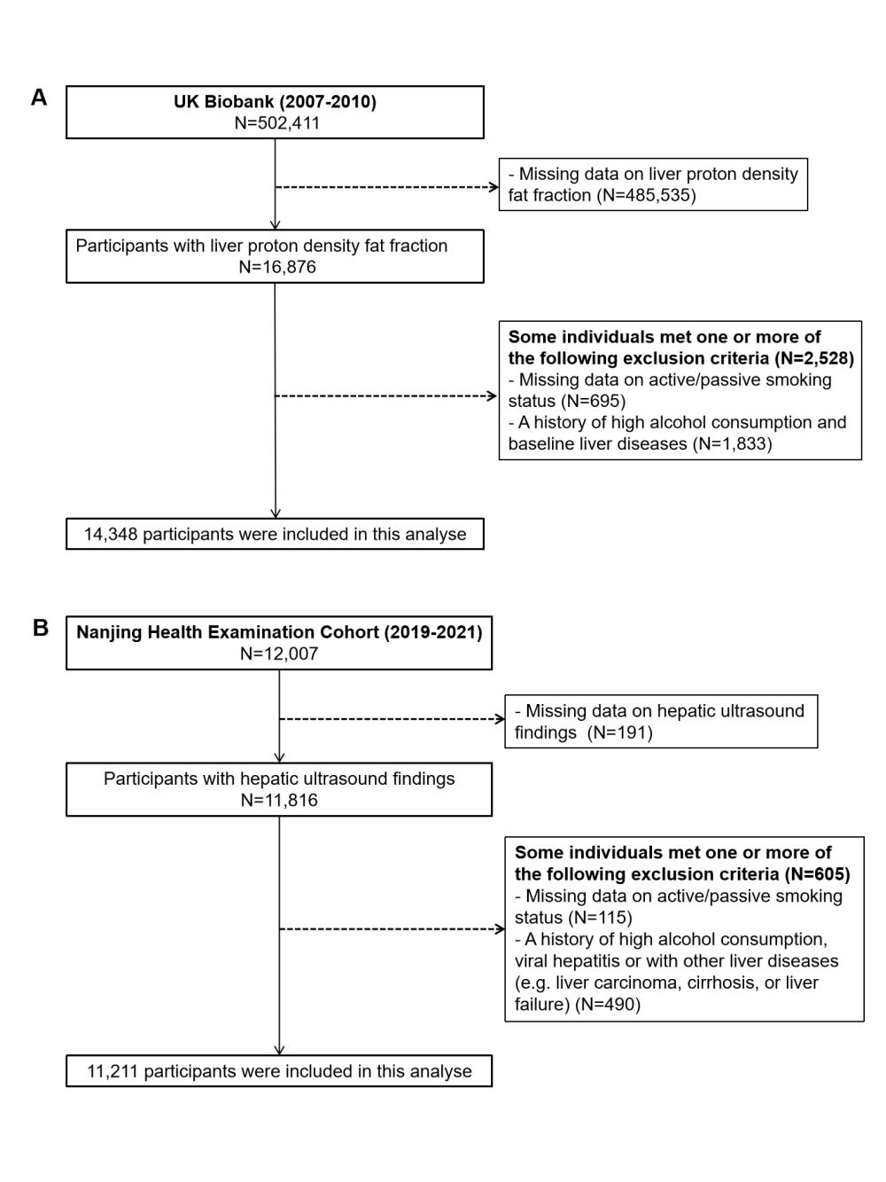
Supplementary Fig. 1. Flowchart for selection of study participants.

