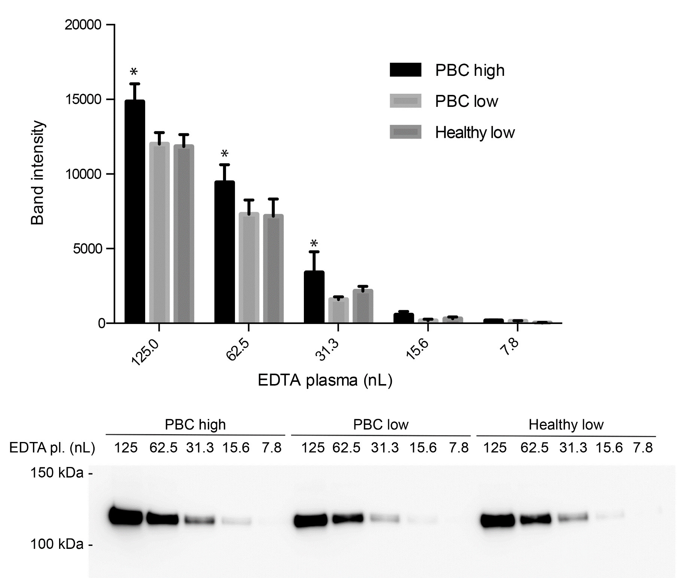
B
A

Supplementary Fig. 2. Test for inter-α-inhibitor heavy chain 4 (ITIH4) by western blot analysis. EDTA plasma from a primary biliary cholangitis (PBC) patient with high ITIH4 (524 µg/mL), a PBC patient with low ITIH4 (256 µg/mL), and a healthy donor with low ITIH4 (202 µg/mL) were analyzed. Dilutions of plasma were loaded and analyzed by western blotting using a mixture of two monoclonal anti-ITIH4 antibodies as detecting antibodies. The procedure is described in detail in the methods section. Panel A depicts the quantification of band intensities from the western blot (Panel B, n=3). The PBC high group was compared to the PBC low group using multiple t-tests assuming identical scatter in the two groups (α=5.0 %) to assess statistical significance.

