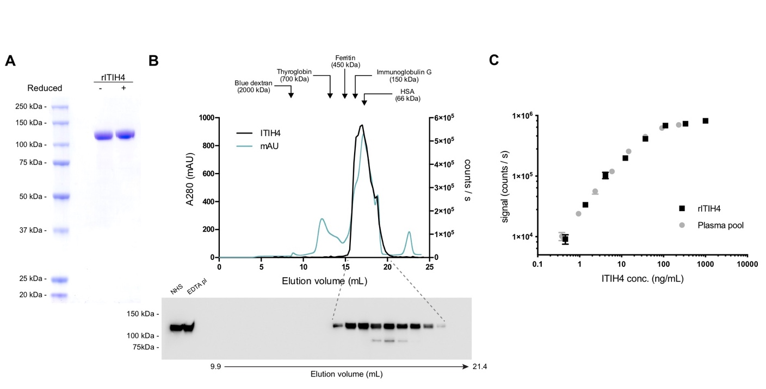
Supplementary Fig. 1. Development of an inter-α-inhibitor heavy chain 4 (ITIH4)-specific immunoassay. (A) Recombinant ITIH4 was expressed in HEK293 cells and purified from the supernatant. The final preparation, which was used to generate anti-ITIH4, was analyzed by SDS-PAGE, reduced, and nonreduced. (B) Validation of assay specificity. EDTA plasma was fractionated by size-exclusion chromatography (SEC), and the elution profile of ITIH4 was determined using the ITIH4 assay. The elution profile of total protein (A280) is plotted on the left Y-axis, while the signals from the ITIH4 assay (ITIH4) are plotted on the right Y-axis (counts per second). Arrows indicate the elution volume of a set of standard proteins. The western blot below the elution profile depicts anti-ITIH4 assays of the indicated fractions from the SEC. Moreover, this blot, to the left, also includes unfractionated human serum and EDTA plasma. Note that minor degradation of ITIH4 is observed during fractionation, which may be caused by local activation of proteases during the experiment despite adding the inhibitor pefabloc to the buffer. These results are representative of three repeated experiments. (C) Titration curves of recombinant ITIH4 and the citrate plasma pool. Dilutions of recombinant ITIH4 or the standard plasma pool were measured in the ITIH4 assay. The error bars depict the standard deviation (n=2).

