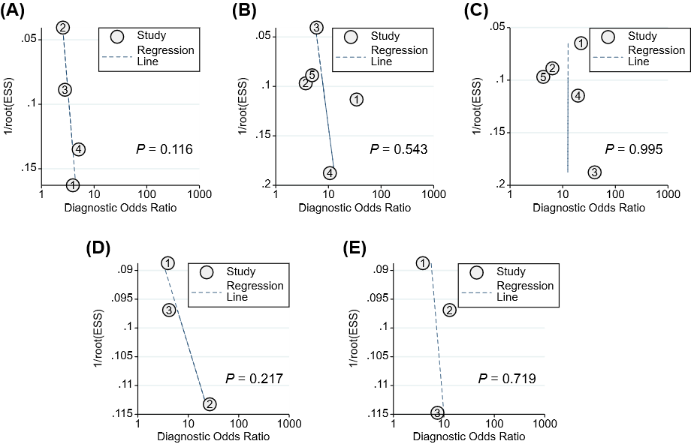

Figure S6. Deeks' funnel plot of HBeAg-related markers in predicting HBeAg loss with pegylated interferon in patients with CHB. (A) Baseline HBeAg, (B) HBeAg at week 12, (C) HBeAg at week 24; (D) HBeAg decline at week 12; (E) HBeAg decline at week 24
1/root (ESS), the inverse of the square root of the effective sample size.

