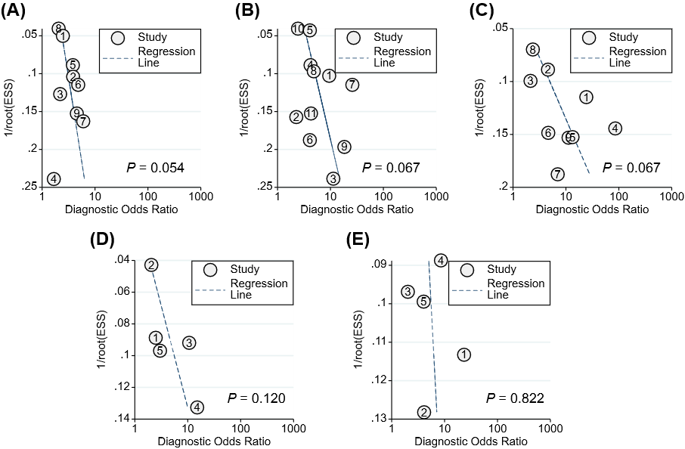

Figure S5. Deeks' funnel plot of HBsAg-related markers in predicting HBeAg loss with pegylated interferon in patients with CHB. (A) Baseline HBsAg, (B) HBsAg at week 12, (C) HBsAg at week 24; (D) HBsAg decline at week 12; (E) HBsAg decline at week 24
1/root (ESS), the inverse of the square root of the effective sample size.

