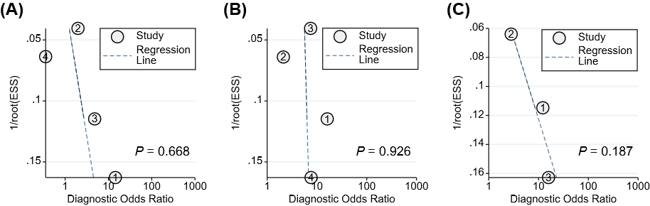

Figure S4. Deeks' funnel plot of HBV-RNA in predicting HBeAg loss with pegylated interferon in patients with CHB. (A) Baseline HBV RNA, (B) HBV RNA at week 12, and (C) HBV RNA at week 24
1/root (ESS), the inverse of the square root of the effective sample size.

