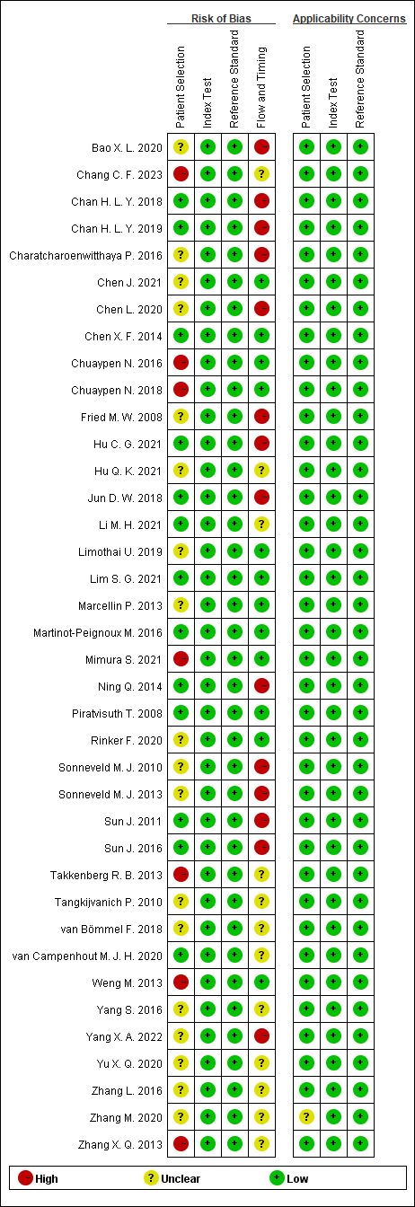

Figure S2. Risk of bias and applicability concerns summary

