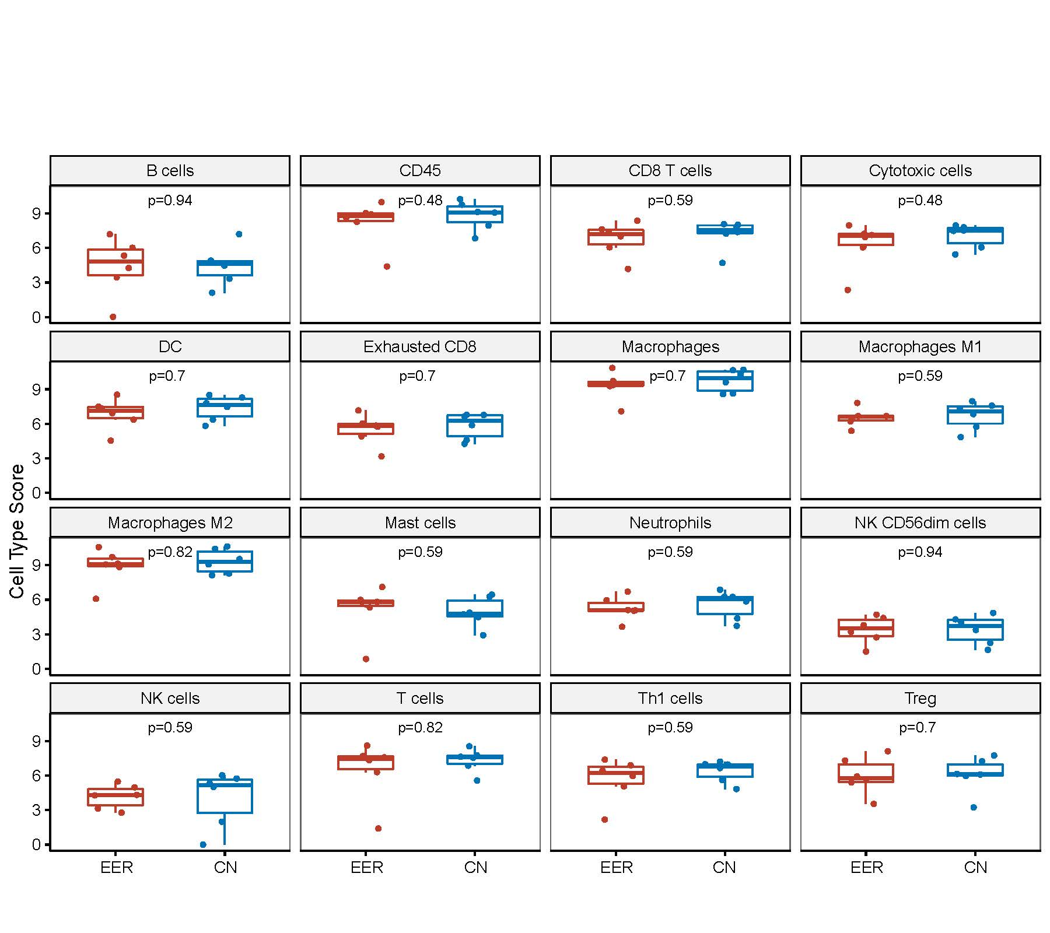
Fig. S3. Comparison of 16 immune cell scores in the EER and control groups (Wilcoxon rank sum test). CD, cluster of differentiation; CN, control normal; DC, dendritic cells; EER, early explosive recurrence; NK, natural killer; Th1, T-helper 1; Th2, T-helper 2; Th17, T-helper 17; Treg, regulatory T cells.

