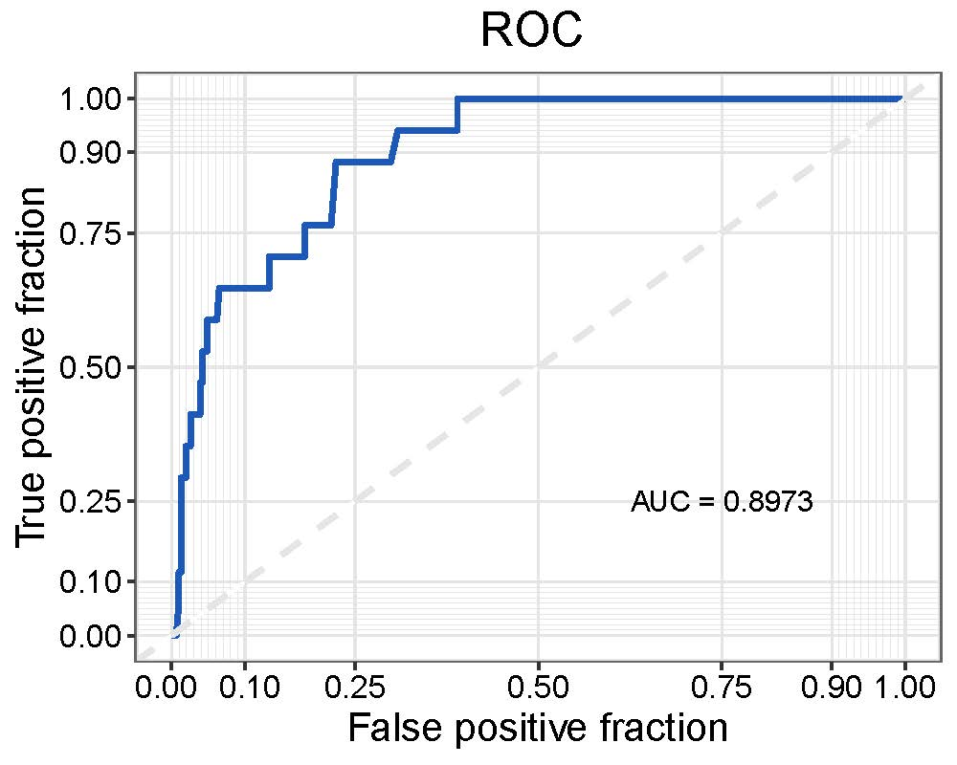
Fig. S2. Area under the curve of receiver operating risk for the EER risk prediction model. AUC, Area under curve; EER, early explosive recurrence; ROC, Receiver Operating Characteristic.

