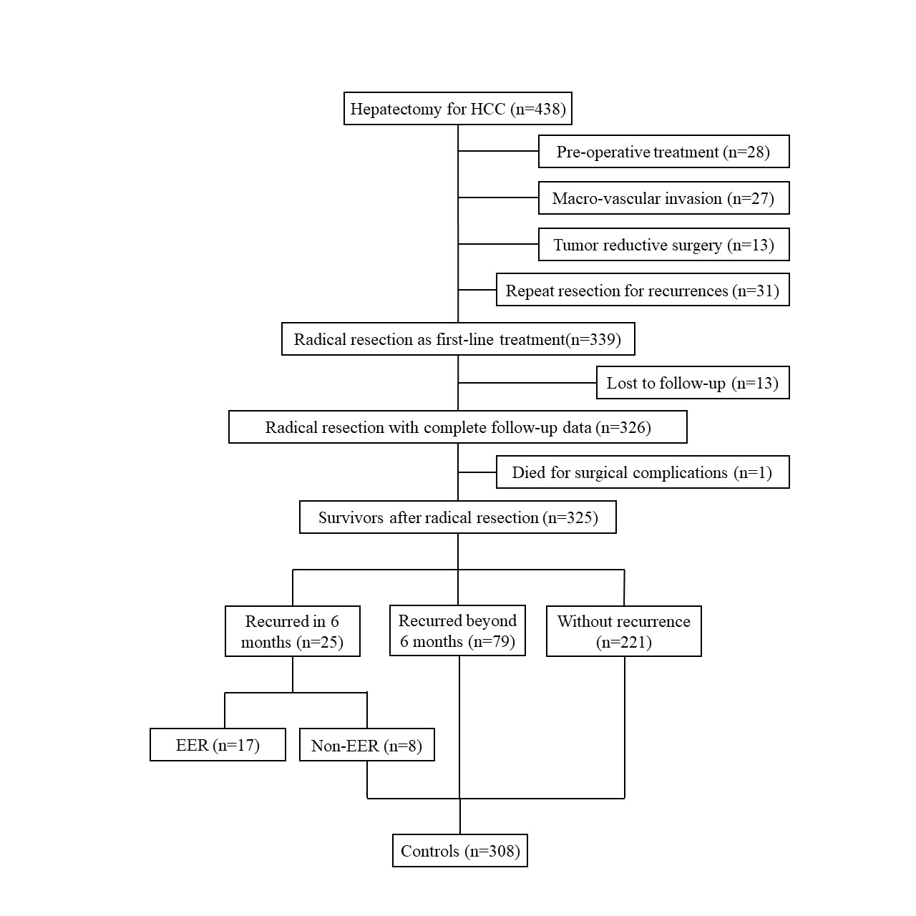
Fig. S1. Flow diagram of the study. EER, early explosive recurrence; HCC, hepatocellular carcinoma.

