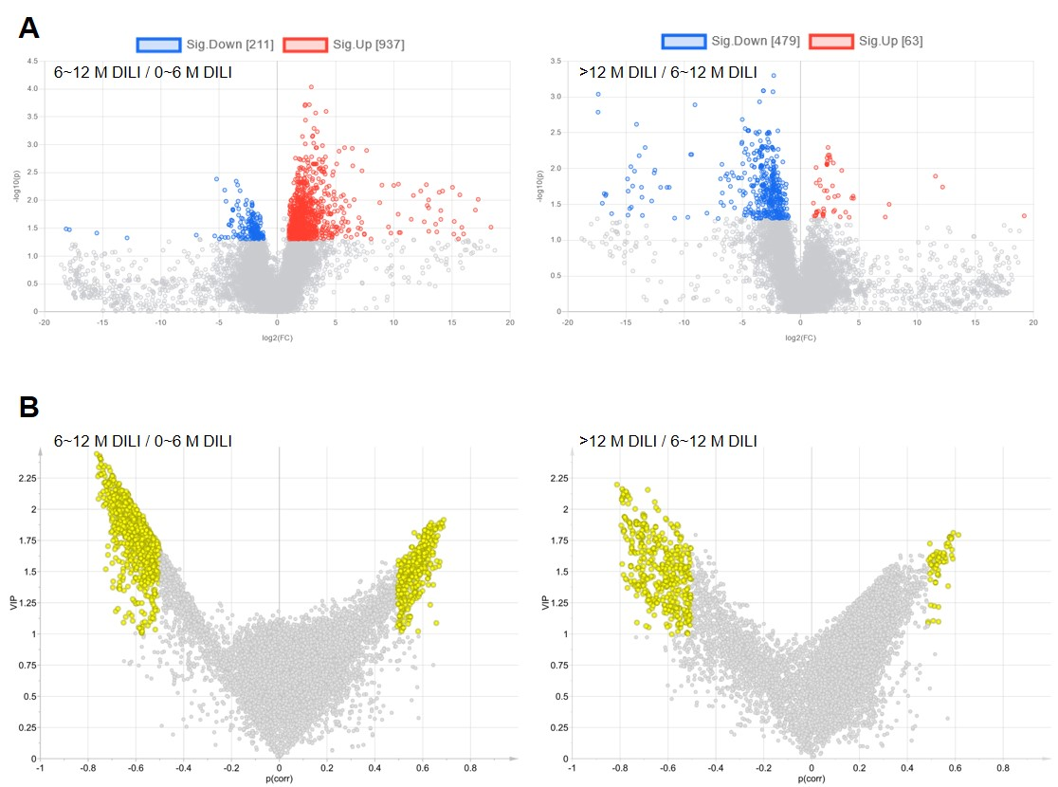
Figure S1. Screening of serum metabolites related to the duration of DILI. (A) Metabolite ions with the fold change (FC) value >2 and P <0.05 were marked with colored plots in ESI- mode. (B) Metabolite ions with variable importance for the projection (VIP) value >1 and |p(corr)| >0.5 were marked with yellow plots.

