Supplementary Material

Materials and Methods
Measurements
The RODAM study data collection was performed according to a well-standardized approach. In Ghana, rural participants were recruited from 15 villages in the Ashanti region. Two cities were chosen (Kumasi and Obuasi) for recruitment and data collection in urban residents. In rural and urban Ghana, participation rates were 76% and 74% respectively. In Amsterdam, 53% of the recruited subjects agreed to participate in the study. In London, this was 75% and in Berlin 68%.

Data obtained by a structured questionnaire were sex, age, education level, physical activity level, smoking, alcohol consumption, and history of T2DM. Physical activity levels were assessed by the second version of the GPAQ, resulting in a categorization of low, moderate, or high levels of physical activity.⁴³ Alcohol consumption was categorized as any or no consumption. Smoking was categorized as current, past, or non-smokers. Categories of education were: none or elementary, lower secondary, higher secondary, and tertiary/university. BP was measured in triplicate after 5 m of rest, with appropriate cuffs. The mean of the two last BP measurements was used for analyses. Assessment of body weight was performed to the nearest 0.1 kg, with scales (SECA 887). Assessment of height was done to the nearest 0.1 cm, by stadiometers (SECA 217). BMI was defined as body weight/height² (kg/m²). Measurement of waist circumference was performed to the nearest 0.1 cm with a tension tape at the midpoint between the iliac crest and the costal margin. Hip circumference was measured over the trochanter major bilaterally, also using a tension tape to the nearest 0.1 cm. WHR was defined as waist circumference (cm)/hip circumference (cm). WHR was considered elevated when ≥0.90 for men and ≥0.85 for women, as defined by the World Health Organization. T2DM was also defined according to the World Health Organization criteria: self-report, use of glucose lowering medication, or fasting blood glucose measurement ≥7.0 mmol/L. Fasting venous blood samples were collected by trained research assistants in all sites. All blood samples were manually processed immediately after collection, according to standard operational procedures. All biochemical analyses were performed in Berlin, with an ABX Pentra 400 chemistry analyzer (ABX Pentra; Horiba ABX, Montpellier, France).

Data analysis
Subset analyses for differences in FLI were performed in migrant groups (participants from Amsterdam, London, and Berlin). Logistic regression models were used to assess associations of elevated FLI (≥60) with migrant status, elevated WHR, and T2DM. In these models, migrant status, elevated WHR, and T2DM were used as independent variables.

Results
FLI and its determinants by location of current residency
In a subset analysis for migrants only, median FLI did not differ significantly (p=0.49) between the three European cities: 44.9 in Amsterdam, 43.3 in London, and 41.9 in Berlin in men. In women, however, participants residing in Berlin had a significantly lower median FLI (38.9) compared to participants from Amsterdam (43.4) and London (52.0) (p<0.001), as given in Supplemental Figure 2.

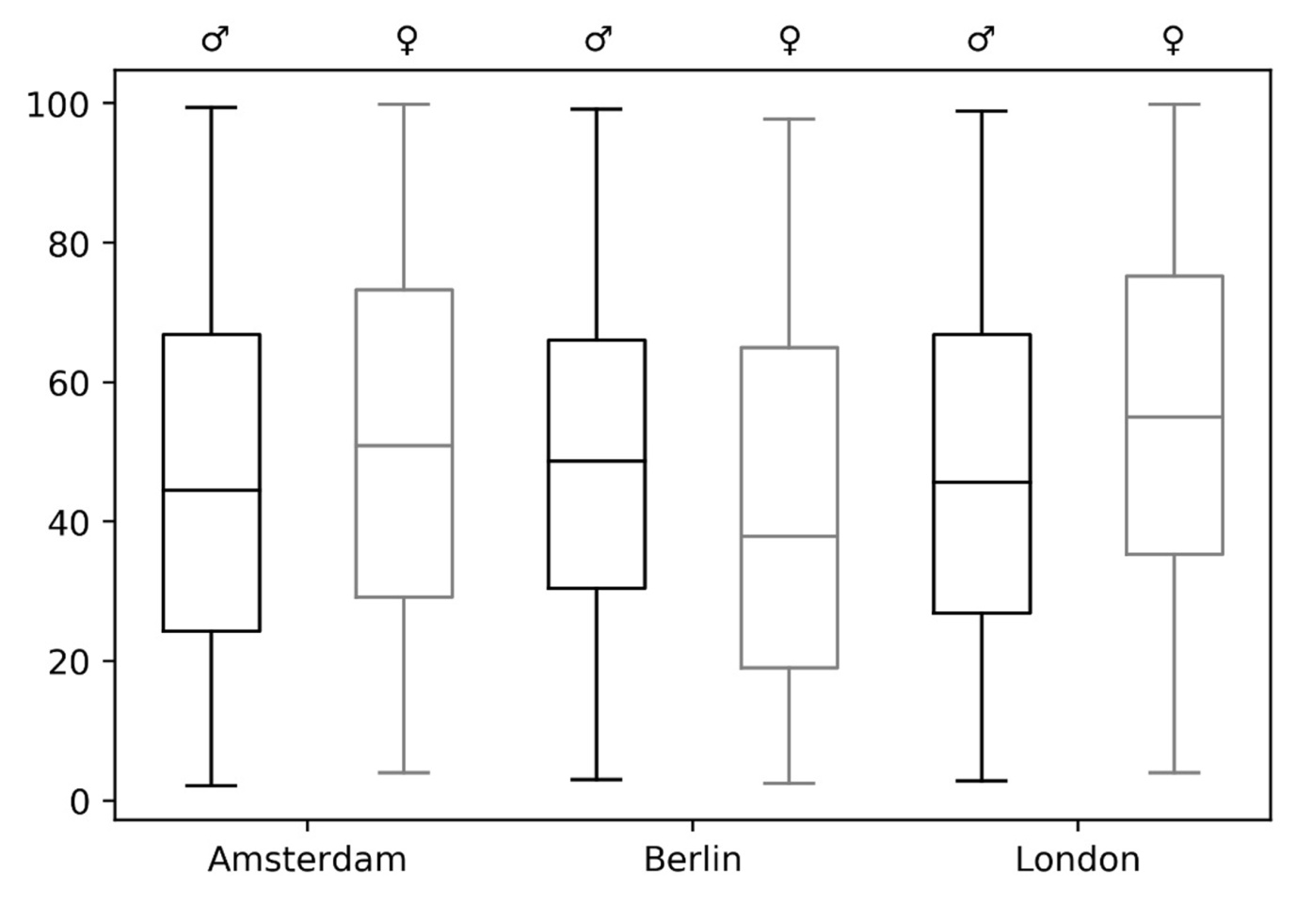
Supplemental Figure 2. FLI in male (black) and female (grey) Ghanaian migrant resident in Amsterdam, Berlin, and London.

