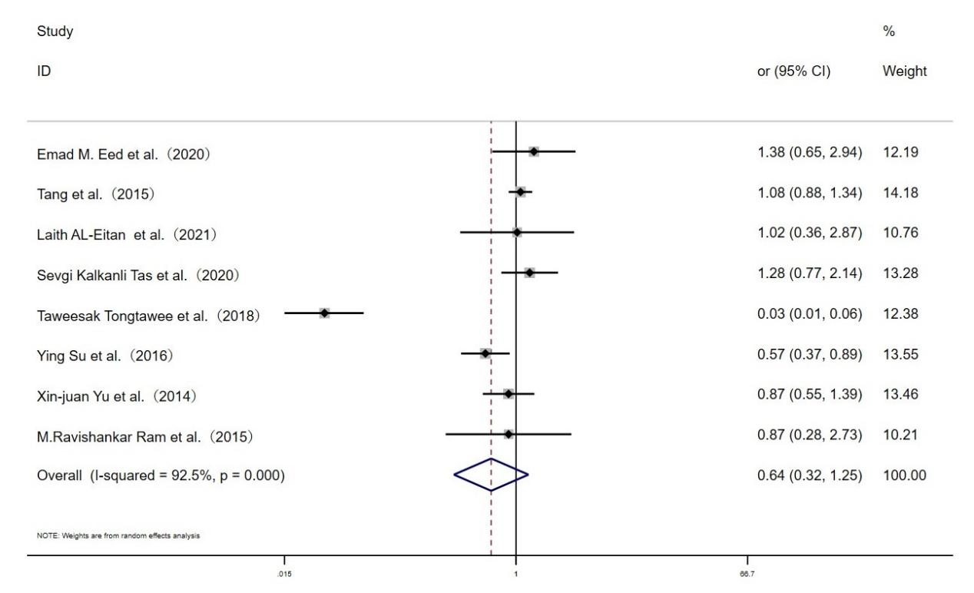
Fig. S4 Forest plot for the associations between TLR10 rs10004195 polymorphism and H.pylori infection risk through heterozygous model (AT vs.TT)

