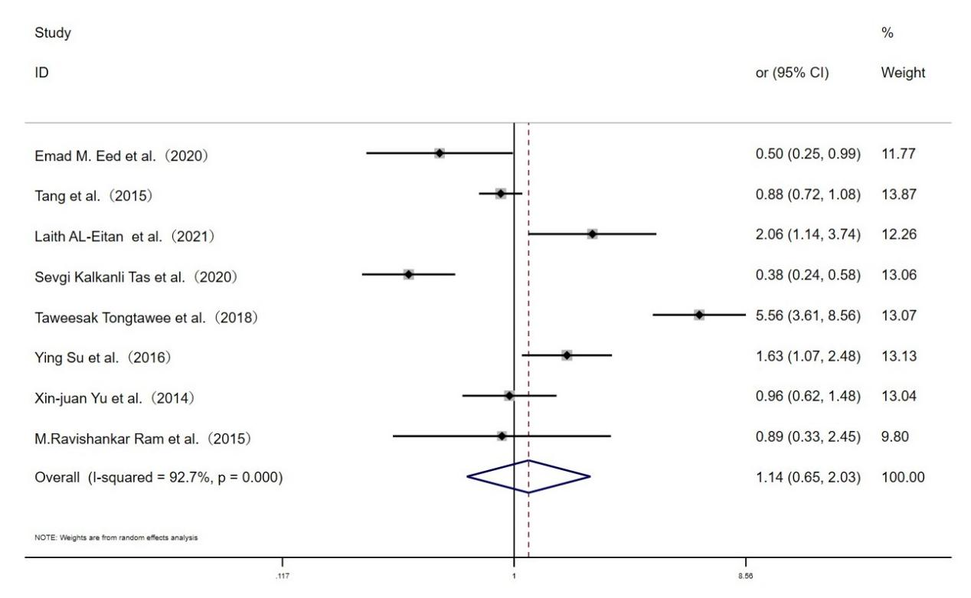
Fig. S3 Forest plot for the associations between TLR10 rs10004195 polymorphism and H.pylori infection risk through dominant genetic model (TT vs.AT+AA)

