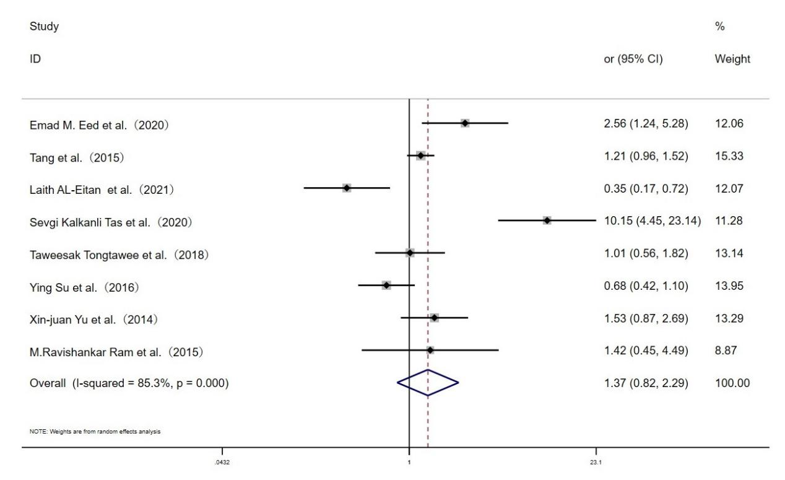
Fig. S2 Forest plot for the associations between TLR10 rs10004195 polymorphism and H.pylori infection risk through homozygous model (AA vs.TT)

