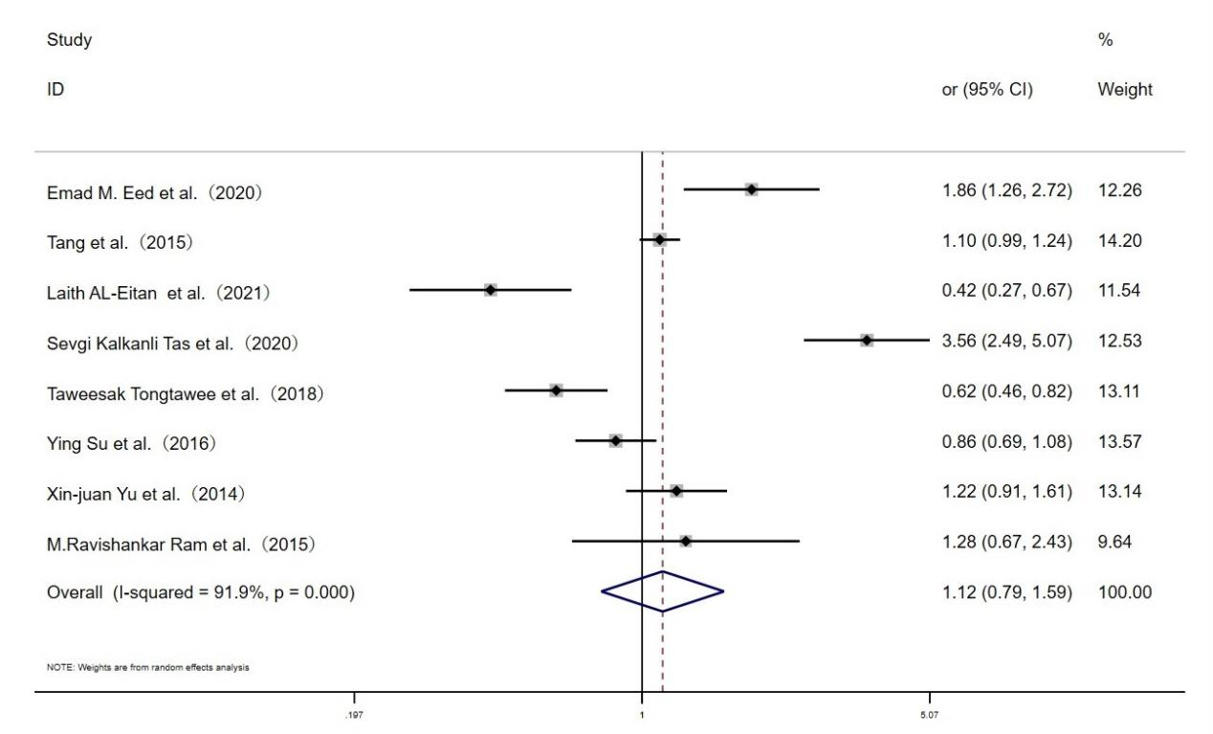Fig. S1 Forest plot for the associations between TLR10 rs10004195 polymorphism and H.pylori infection risk through allelic model (A vs.T)

