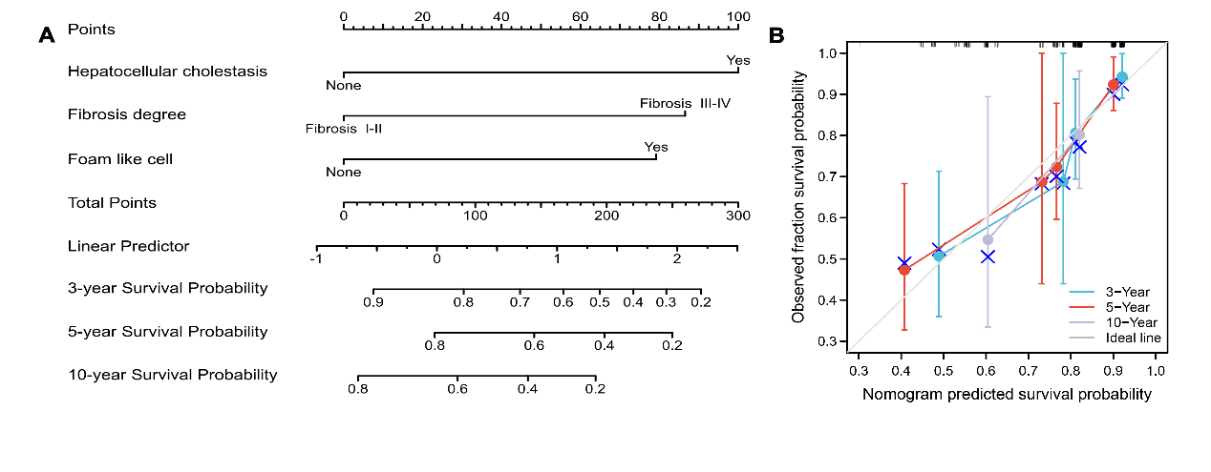
Supplementary Fig. 2. Nomogram to estimate the risk of transplant-free survival rate in VBDS patients and validation plot of the predictive performance of the nomogram. (A) The nomogram to estimate the risk of transplant-free survival rate in patients with VBDS. Each variable was given a point on the basis of the nomograms and by adding the given points of all factors, we finally obtained the total points to estimate 3-, 5- and 10-year probabilities of transplant-free survival of the individual patient from the nomogram. (B) Validity of the predictive performance of the nomogram. C-index (0.746) represents the satisfactory prediction performance of our model. VBDS, vanishing bile duct syndrome.

