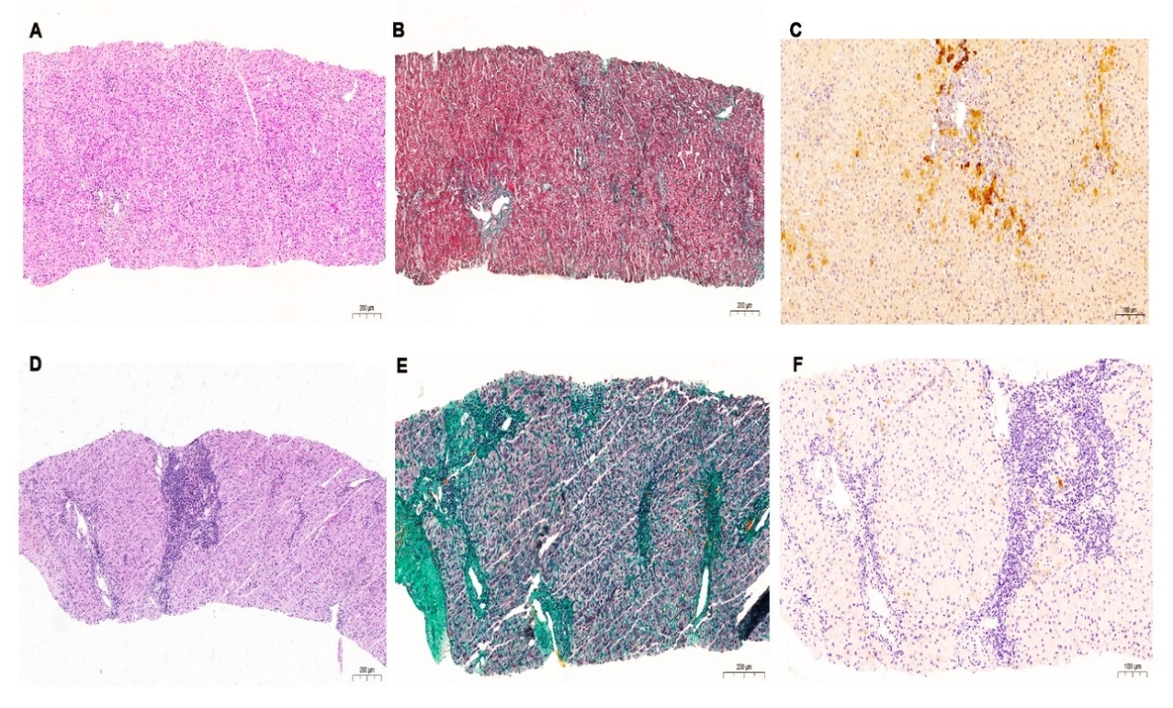

Supplementary Fig. 1. Histological features of the two different forms of VBDS. (A-C) Patient with liver biopsy displaying “bland” ductopenia without obvious inflammation or significant fibrosis (A: Hematoxylin-eosin; B: Masson trichrome; C: Cytokeratin 7); (D-F) Patient with liver biopsy exhibiting ductopenia associated with portal-periportal inflammation and advanced fibrosis (D: Hematoxylin-eosin; E: Masson trichrome; F: Cytokeratin 7). VBDS, vanishing bile duct syndrome.

