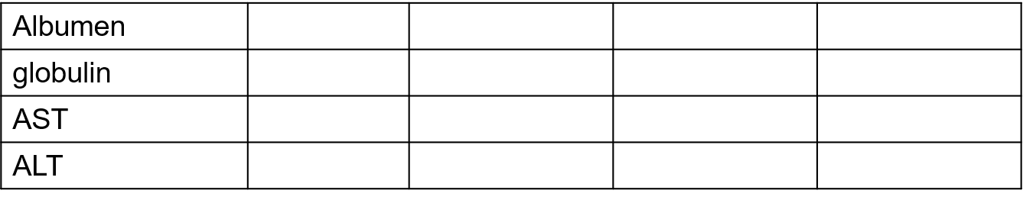
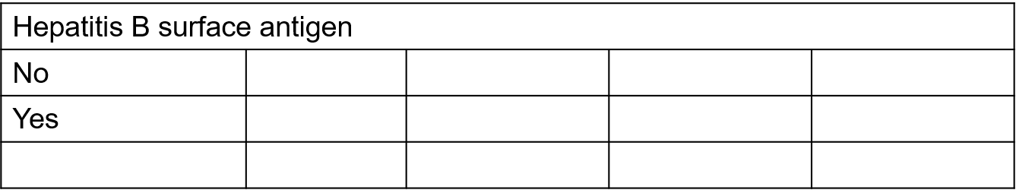
Supplementary Table 1. Basic characteristics of the donors
Characteristics | steatotic liver (45) |  | P value
Characteristics | No(n=24) | Yes(n=21)
Gender
male | 16 | 11 | 0.5504
female | 9 | 10
age, y | 52.0(30-70) | 50.9(30-72) | 0.7225
Height | 166.9(151.7-184.8) | 170.5(153.9-190.2) | 0.2405
weight | 68.2(38.4-85.5) | 72.0(40.8-89.5) | 0.3048
Disease etiology |  |  | 0.987
Hepatitis B virus | 6 | 4
Hepatitis C virus | 3 | 2
Alcohol | 2 | 2
malignant tumor | 9 | 10
others | 4 | 3
Pretransplant laboratory values
White blood cell | 12.8(4.1-21.7) | 11.1(2.9-20.1) | 0.2101
Red blood cell | 3.7(1.9-5.5) | 3.3（1.5-5.9） | 0.1517
Hemoglobin | 102.6(62.3-169) | 110.9(72.9-161.5) | 0.2348
Platelets | 181.4(61.1-427.7) | 153.8(45.8-275.1) | 0.2321
Lymphocyte | 1.6（0.3-8.1） | 1.1（0.2-2.1） | 0.1458
Mononuclear cell | 0.7（0.3-2.3） | 0.9（0.1-2.1） | 0.2236
Neturophil | 10.8(2.3-20.4) | 9.5(2.5-20.1) | 0.3520
Eosinophilic cell | 0.2(0.1-0.6) | 0.1(0-0.3) | 0.0971
Basophil cell | 0.2(0.1-0.4) | 0.1(0-0.2) | 0.1111
C-reactive protein | 90.5(14.1-359.6) | 72.8(11.3-207.2) | 0.4049
PCT | 10.5(3.5-38) | 25.3(3.6-184.4) | 0.1023
alkaline phosphatase | 72.5(42.3-161.5) | 82.0(46.8-179.0) | 0.2549
Total protein | 63.0(43.5-85.9) | 69.0(8.8-260.3) | 0.5967
Albumen | 32.2(20.7-46.5) | 33.0(23.7-51.8) | 0.6781
globulin | 25.8(18.0-44.0) | 24.2(18.1-35.1) | 0.3033
AST | 55.1(7.8-200.3) | 66.2(19.3-260.4) | 0.4950
ALT | 79.6(6.3-352.1) | 90.7(8.8-460.8) | 0.7350
Hepatitis B surface antigen |  |  | 0.9336
No | 24 | 21
Yes | 0 | 0

