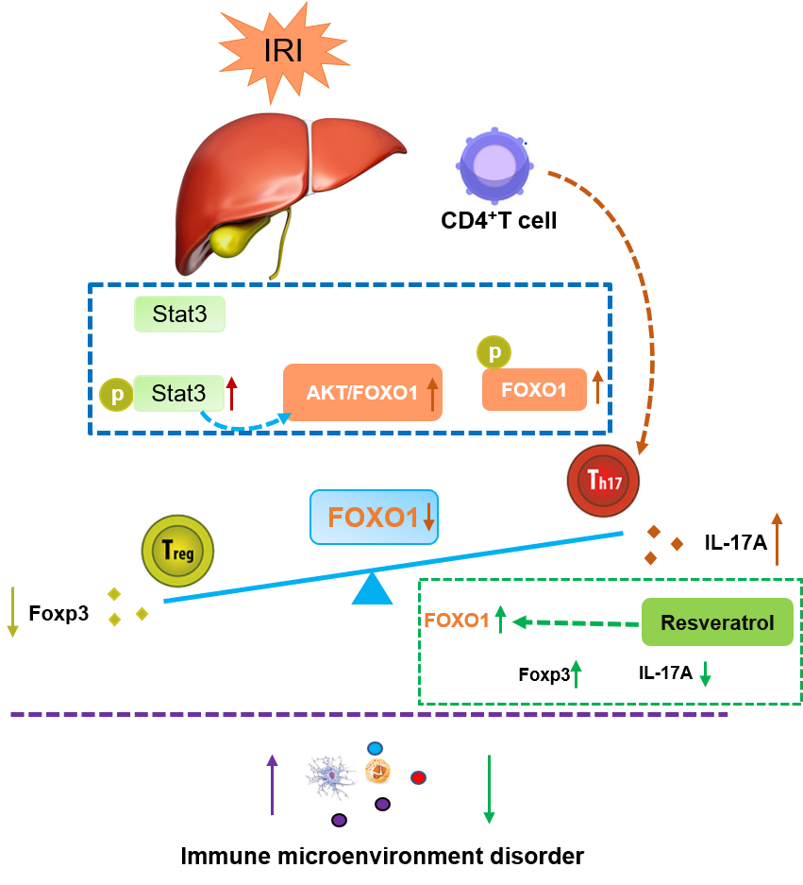
Supplementary Fig. 1. Graphical abstract. Liver IR-stress caused Th17/Treg imbalance and FOXO1 down-regulation by activating the AKT/Stat3/FOXO1 signaling pathway. Up-regulation of FOXO1 reversed Th17/Treg cytokine imbalance and altered the liver inflammation environment.

