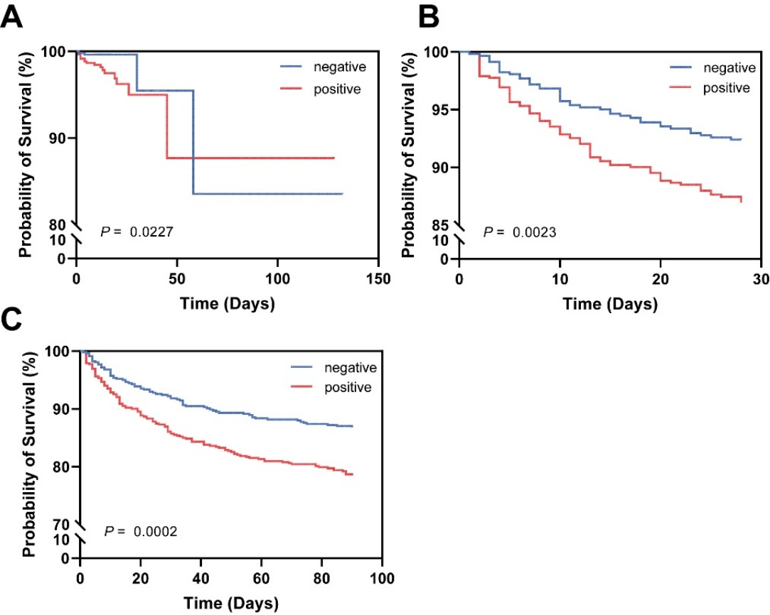

**Supplementary Figure 3. (A) Probability of in-hospital survival in patients between positive and negative cultures. (B) Probability of 28-days survival in patients between positive and negative cultures. (C) Probability of 90-days survival in patients between positive and negative cultures.**