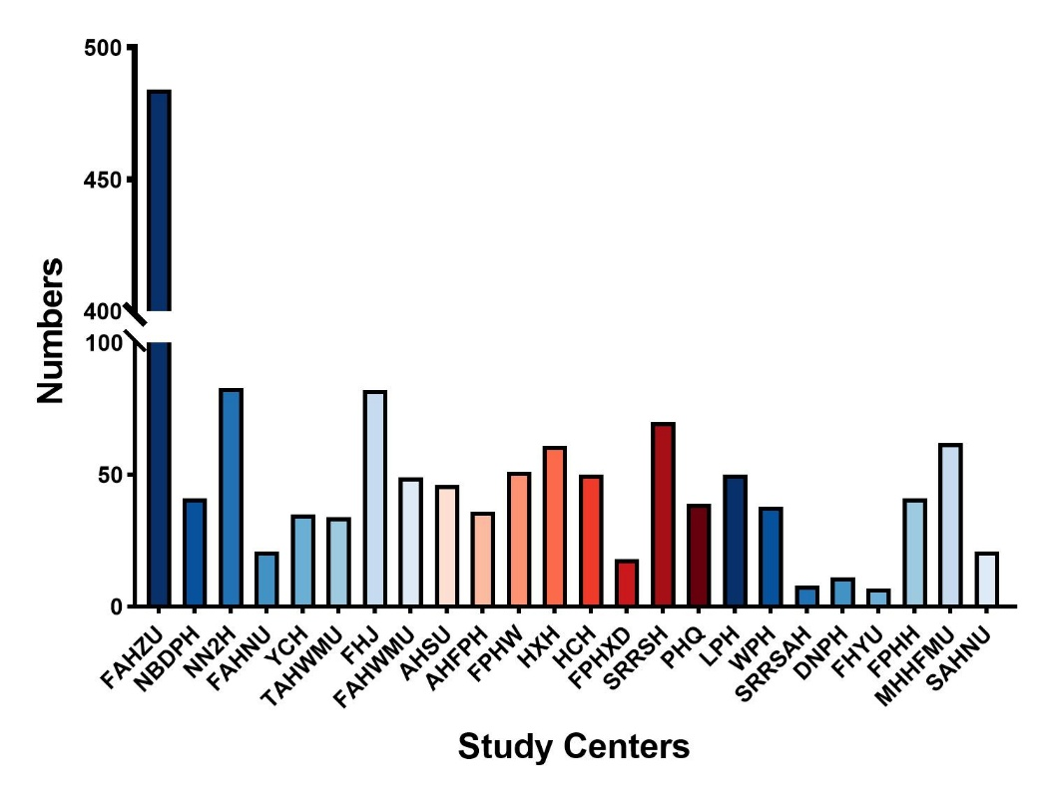

**Supplementary Figure 2. Patients included in each of the 24 study centers**

Abbreviation: FAHZU, The First Affiliated Hospital of Medical School of Zhejiang University; NBDPH, Ningbo Beilun District People’s Hospital; NN2H, Ningbo No.2 Hospital; FAHNU, The First Affiliated Hospital of Ningbo University; YCH, Yiwu Central Hospital; TAHWMU, The Third Affiliated Hospital of Wenzhou Medical University; FHJ, The First Hospital of Jiaxing; FAHWMU, The Fifth Affiliated Hospital of Wenzhou Medical University; AHSU, Affiliated Hospital of Shaoxing University; AHFPH, Affiliated Hangzhou First People’s Hospital; FPHW, the First People’s Hospital of Wenling; HXH, Hangzhou Xixi Hospital; HCH, Huzhou Central Hospital; FPHXD, The First People’s Hospital of Xiaoshan District; SRRSH, Sir Run Run Shaw Hospital; PHQ, The People’s Hospital of Quzhou; LPH, Linyi People's Hospital; WPH, Weifang People’s Hospital; SRRSAH, Sir Run Run Shaw Alaer Hospital; DNPH, Dongguan Ninth People’s Hospital; FHYU, First Hospital of Yangtze University; FPHH, The Fifth People’s Hospital of Huaian; MHHFMU, Mengchao Hepatobiliary Hospital of Fujian Medical University; SAHNU, The Second Affiliated Hospital of Nanchang University.