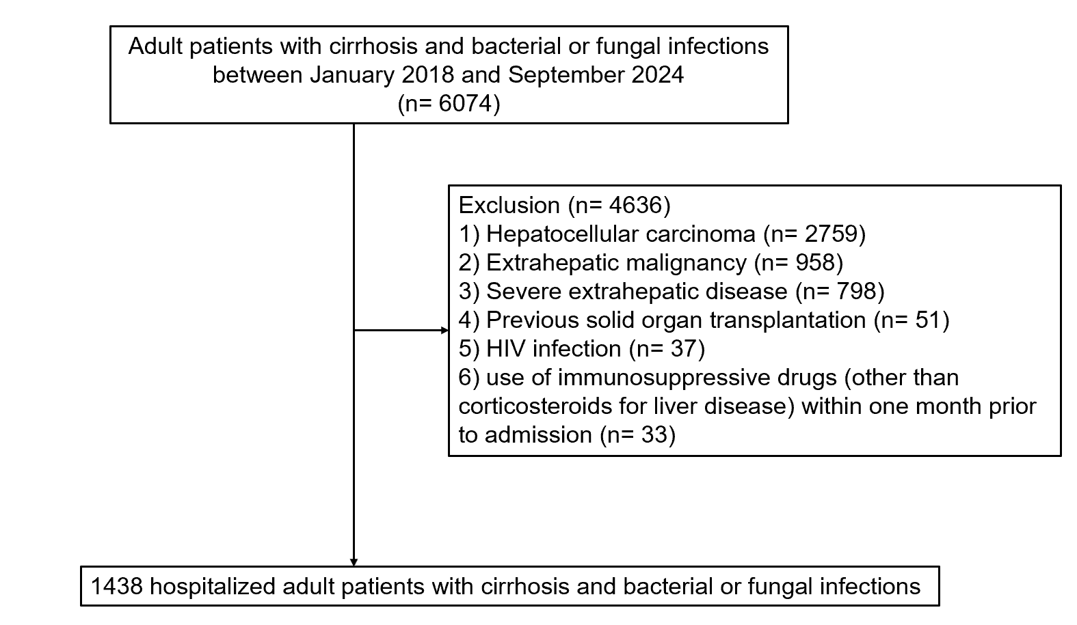

**Supplementary Figure 1. Flow chart of the participants enrolled**