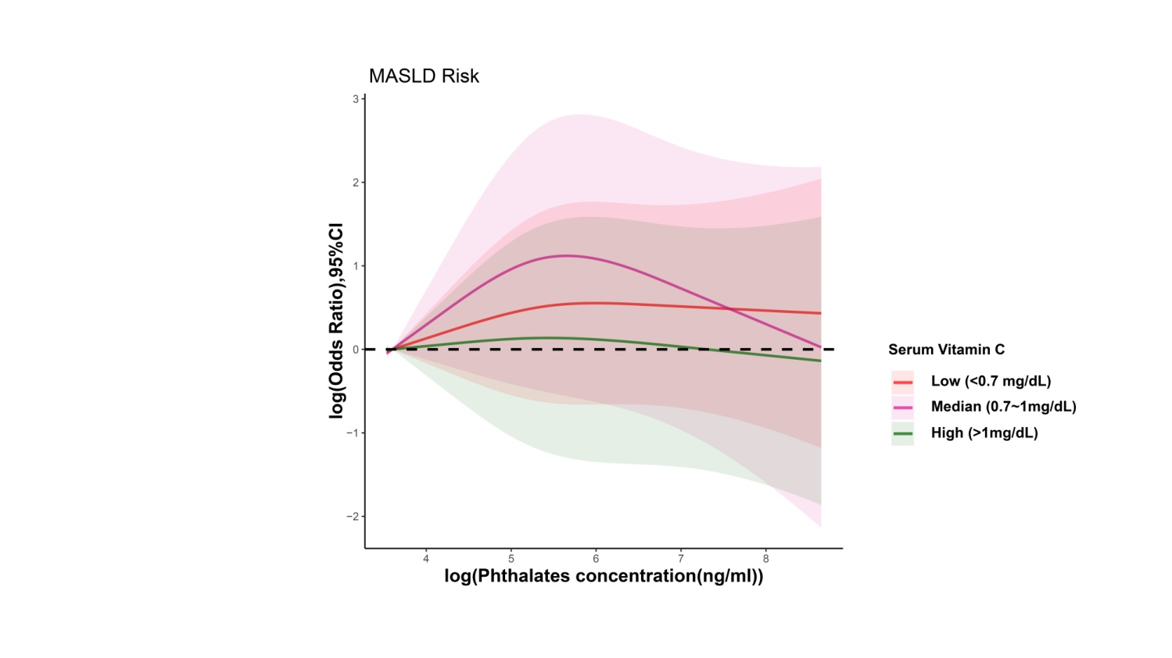

**Supplementary Fig. 2 Association between phthalates and MASLD at different serum vitamin C concentration levels.** The restricted cubic spline model was adjusted for urinary creatinine, age, sex, race, BMI, hypertension, diabetes, poverty-income ratio, education level, smoking status, drinking status, leisure time physical activity, total energy intake, dietary supplement usage, HEI-2020, and CDAI. The shaded area represents the 95% confidence interval. The analysis for serum data was conducted using NHANES 2005-2006 and 2017-2018, with a total of 979 participants included. CDAI, composite dietary antioxidant index; CI, confidence interval; HEI-2020, healthy eating index-2020; OR, odds ratio; MASLD, metabolic dysfunction-associated steatotic liver disease.