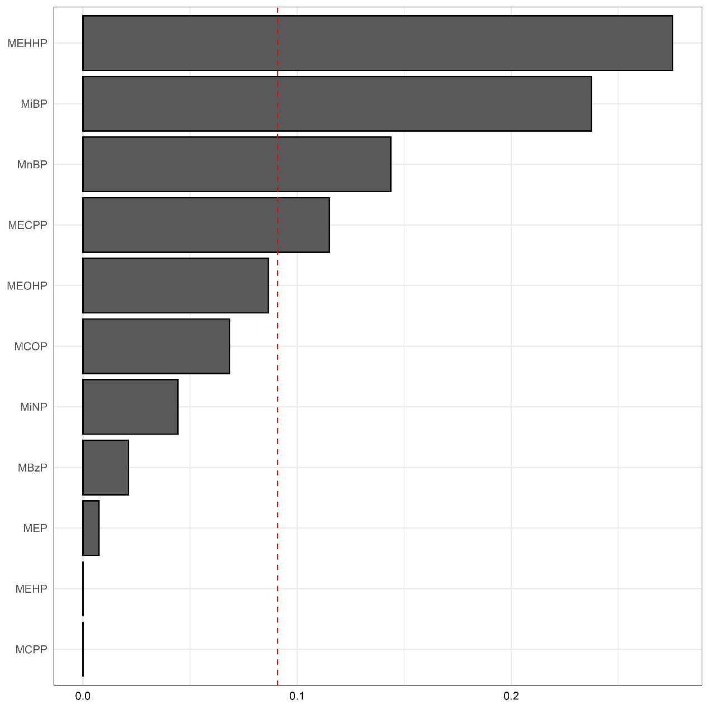

**Supplementary Fig. 1 Weights of each phthalate in the full population.** The chemicals with statistically significant weights in the mixture were MEHHP, MiBP, MnBP, and MECPP. The model was fully adjusted for urinary creatinine, age, sex, race, BMI, hypertension, diabetes, poverty-income ratio, education level, smoking status, drinking status, leisure time physical activity, and total energy intake. MBzP, monobenzyl phthalate; MCPP, mono-(3-carboxypropyl) phthalate; MCOP, mono-(carboxyoctyl) phthalate; MECPP, mono-(2-ethyl-5-carboxypentyl) phthalate; MEP, mono-ethyl phthalate; MEHP, mono-(2-ethylhexyl) phthalate; MEHHP, mono-(2-ethyl-5-hydroxylhexyl) phthalate; MEOHP, mono-(2-ethyl-5-oxohexyl) phthalate; MiBP, mono-isobutyl phthalate; MiNP, mono-isononyl phthalate; MnBP, mono-n-butyl phthalate.