Supplementary Materials

Methods
Cell proliferation viability of the BM-MSCs labeled with Au-Fe₃O₄ silica NPs
The BM-MSCs was co-incubated with 2.0 OD Au-Fe₃O₄ silica NPs for 24 hours. Then the labeled BM-MSCs were cultured in 96-well plates. Cell proliferation viability of the labeled BM-MSCs was determined within 7 days using a CCK-8 assay (Shanghai Yisheng Biotechnology Co., Ltd, China).

Transmission electron microscopy of Au-Fe₃O₄ silica NPs labeled BM-MSCs
BM-MSCs labeled with Au-Fe₃O₄ silica NPs were added into a 6-well plate, and collected after 24, 48, 72, and 96 h of culture, respectively. The labeled BM-MSCs were fixed with electron microscope fixative solution (G1102, Servicebio, China) for no more than 2 days and observed with a transmission electron microscope (HT7800; Hitachi, Japan).

Effectiveness of treatment for LC after administering Au-Fe₃O₄ silica NPs-labeled BM-MSCs
After infusion of BM-MSCs labeled with Au-Fe₃O₄ silica NPs for one month, 2 mL blood was collected from tail vein of SD rats with 24 G indwelling needle (Braun, Malaysia). The hematological indexes related to liver function (AST, ALT, ALB, TBIL) and liver fibrosis (hyaluronic acid and type IV collagen fiber) were detected. The rats were sacrificed after blood collection, and the liver tissue was taken. Masson staining was performed to observe the liver fibrosis in each group to evaluated the effectiveness of treatment in each group.

Statistical analysis
SPSS 22.0 statistical software was used to fit the curves for the data in Figure 2A and Figure 2B. The general linear model was used to test the trend between groups for the data in Figure 3B. For Figure 3C, one-way analysis of variance was used for intergroup comparisons, and further pairwise comparison was carried out using Tukey’s method. The p-values <0.05 were considered statistically significant.

Results
Characterization of the distribution of Au-Fe₃O₄ silica NPs-labeled BM-MSCs in the liver via different infusion routes
72 h after the infusion of Au-Fe₃O₄ silica NPs-labeled BM-MSCs in each group of rats, Prussian blue staining in the hepatic artery group showed that blue-stained BM-MSCs were not only abundantly distributed in the portal vein area, but also in the fibrous septum. However, in the tail vein group, the blue-stained BM-MSCs were only distributed in the portal vein area, and there was no obvious blue-stained BM-MSCs distribution was observed in the fibrous septum (Supplementary Fig. 1).

Transhepatic arterial infusion of Au-Fe₃O₄ silica NPs-labeled BM-MSCs is more effective in the treatment of LC
One month after the infusion of Au-Fe₃O₄ silica NPs-labeled BM-MSCs, the levels of liver function and fibrosis-related hematological markers including AST, ALT, ALB, TBIL, hyaluronic acid, and type IV collagen fibers were significantly improved in the hepatic artery and tail vein groups compared with those in the control group (p<0.05). Among them, the levels of AST, ALB, hyaluronic acid and type IV collagen fibers were improved significantly in the hepatic artery group compared with those in the tail vein group (Supplementary Fig. 2A).
Masson staining showed that compared with the control group, one month after BM-MSCs infusion, liver fibrosis in the hepatic artery group and the tail vein group was significantly alleviated. Meanwhile, compared with the tail vein group, the thickness of fibrous septum of the liver tissue in the hepatic artery group was decreased, indicating that hepatic fibrosis was significantly alleviated.
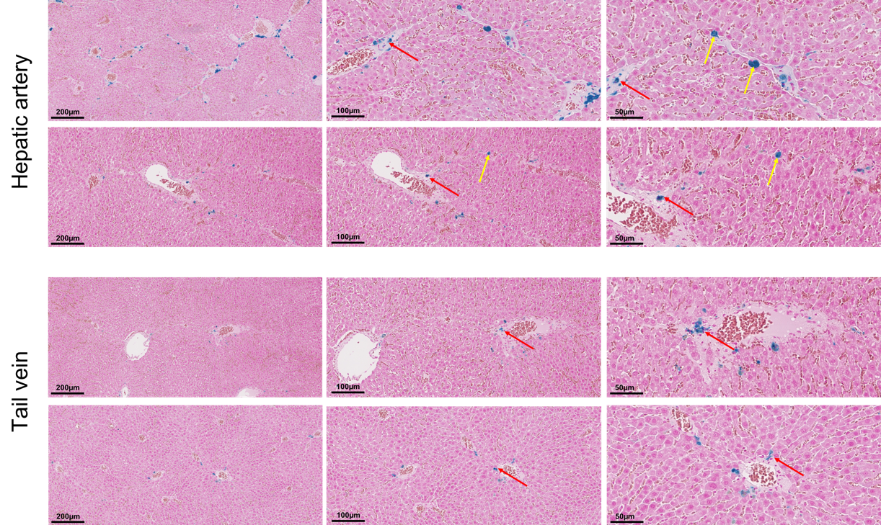
Supplementary Fig. 1. Prussian blue staining of rat liver 72 h after administering BM-MSCs labeled with Au-Fe₃O₄ silica NPs. In the hepatic artery group, the distribution of Prussian blue-stained BM-MSCs in the portal area was significantly increased, and was also seen in the fibrous septa. In the tail vein group, blue-stained BM-MSCs were mainly distributed in the portal area. Red arrows show the distribution of blue-stained BM-MSCs in the portal area. Yellow arrows show the distribution of blue-stained BM-MSCs in the fibrous septa. BM-MSCs, bone marrow-derived mesenchymal stem cells; NPs, nanoparticles.
Supplementary Fig. 2. The efficacy of Au-Fe₃O₄ silica NPs-labeled BM-MSCs in the treatment of liver cirrhosis through different infusion routes. (A) Liver function and fibrosis hematological indexes were measured. AST, ALB, hyaluronic acid, and type IV collagen fibers were significantly improved in the hepatic artery group compared with those in the tail vein group. (B) Masson staining of liver tissues of rats in all groups. The severity of rats liver fibrosis in the hepatic artery group was significantly alleviated compared with that in the tail vein group. *p<0.05. BM-MSCs, bone marrow-derived mesenchymal stem cells; NPs, nanoparticles; AST, aspartate aminotransferase; ALT, alanine aminotransferase; ALB, albumin; TBIL, total bilirubin.

