Table S1. Summary table with the subjects’ characteristics.
Patient identifier | Gender | Body mass index | Average heart rate - bpm | Framingham risk scale
1 | F | 43.87 | 78.11 | High
2 | F | 30.36 | 55.71 | High
3 | F | 34.21 | 83.58 | Low
4 | F | 53.41 | 65.23 | High
5 | F | 55.47 | 89.34 | Moderate
6 | M | 46.60 | 66.36 | Low
7 | F | 42.29 | 63.6 | High
8 | F | 43.07 | 70.31 | Low
9 | F | 25.85 | 75.99 | Moderate
10 | F | 72.40 | 82.82 | Low
11 | M | 46.06 | 60.34 | Moderate
12 | F | 43.26 | 59.25 | Low
13 | F | 48.18 | 64.64 | Low
14 | F | 51.46 | 103.04 | High
15 | F | 51.31 | 85.30 | Low
16 | F | 43.37 | 67.79 | Moderate
17 | F | 28.52 | 68.66 | Low
18 | F | 28.71 | 64.40 | Low
19 | F | 48.90 | 87.29 | High
20 | M | 60.60 | 97.26 | High
21 | M | 52.32 | 82.38 | Moderate
22 | F | 54.87 | 84.92 | High
23 | F | 49.05 | 70.58 | Moderate
24 | F | 42.57 | 63.88 | High
25 | F | 61.09 | 66.93 | Low
26 | F | 41.33 | 94.79 | Moderate
27 | M | 38.96 | 63.18 | High
28 | M | 21.72 | 46.34 | Moderate
29 | F | 35.88 | 81.60 | High
30 | F | 34.17 | 91.30 | Low
31 | F | 50.24 | 84.59 | Low
32 | F | 29.28 | 58.25 | Moderate
33 | F | 51.56 | 65.19 | Moderate
34 | F | 55.58 | 80.67 | High
35 | M | 37.56 | 73.43 | Moderate
36 | F | 29.76 | 55.75 | Low
37 | F | 43.91 | 95.35 | High
38 | F | 29.78 | 78.20 | Moderate
39 | F | 25.39 | 76.54 | Low
40 | F | 53.26 | 74.81 | Low
41 | F | 46.56 | 76.95 | Low
42 | F | 47.87 | 64.07 | High
43 | F | 37.39 | 71.95 | High
44 | F | 28.96 | 65.73 | Low
45 | F | 43.34 | 91.63 | Low
46 | F | 48.07 | 78.70 | Low
47 | F | 32.65 | 66.78 | Moderate
48 | F | 38.59 | 63.13 | High
49 | F | 39.06 | 70.47 | High
50 | F | 39.30 | 78.41 | Low
51 | F | 47.89 | 83.39 | Low
52 | F | 40.75 | 59.91 | Low
53 | F | 33.61 | 45.28 | Moderate

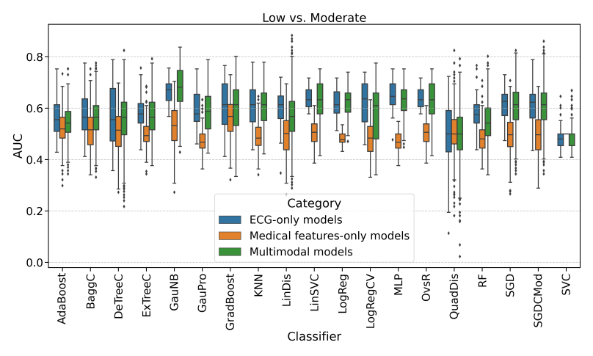 | 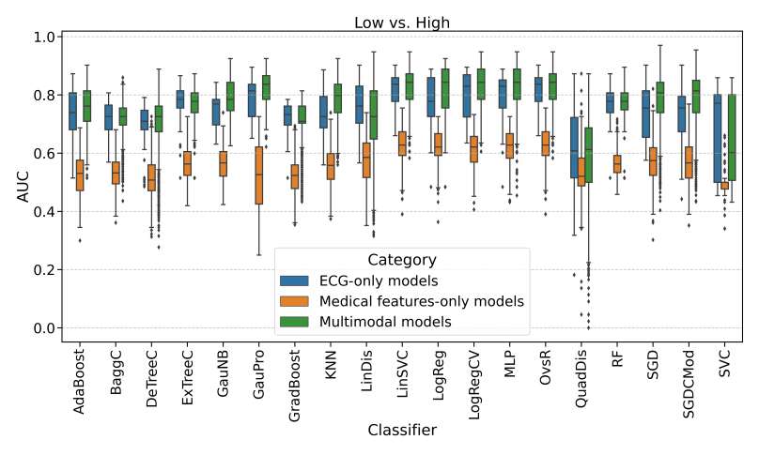
a | b
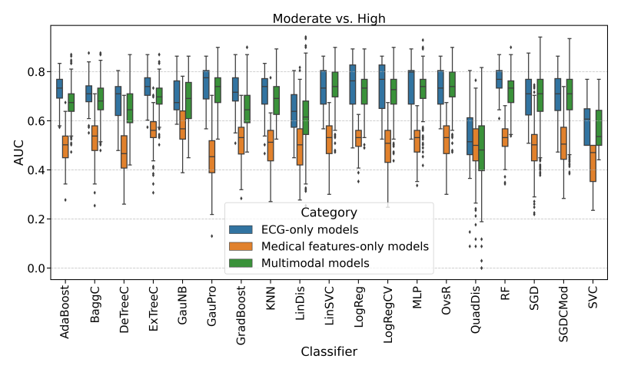 | 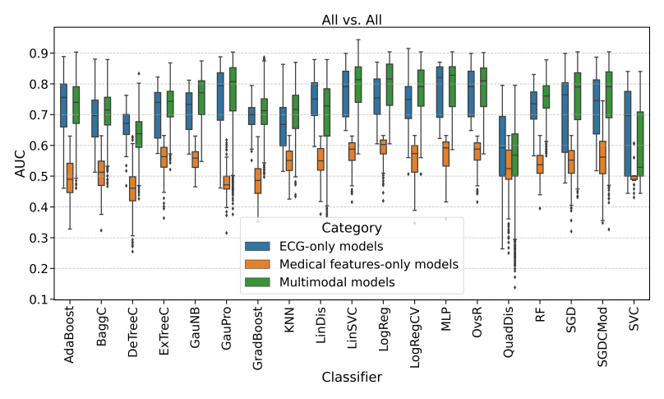
c | d

Fig. S1. Area under the curve (AUC) Boxplots of every classifier performance per category per comparison group. (a) AUC Boxplots for the comparison Low vs. Moderate; (b) AUC Boxplots for the comparison Low vs. High; (c) AUC Boxplots for the comparison Moderate vs. High; (d) AUC Boxplots for the comparison All vs. All.

