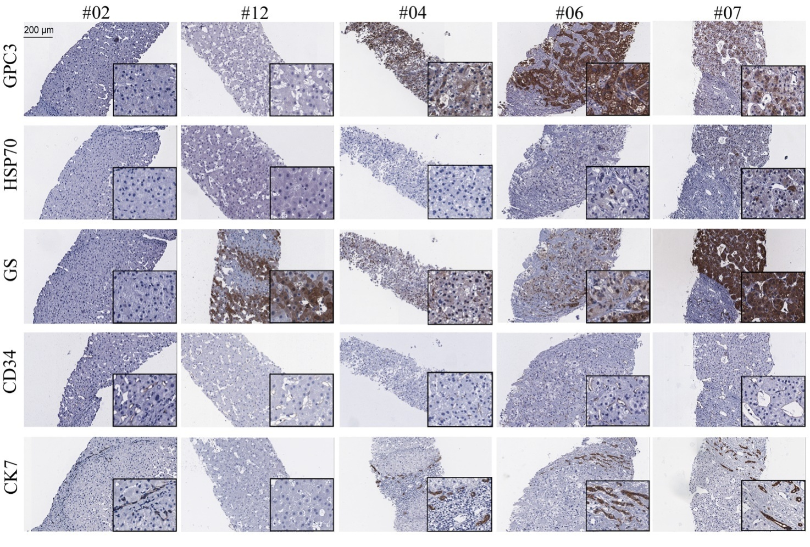
Supplementary Fig. 1. Representative images of the five HCC-related tissue markers in the biopsy tissues. The biopsy tissues from the 14 cases were stained with GPC3, HSP70, GS, CD34, and CK7, and representative images from case #02, #04, #06, #07, and #12 are shown. HCC, hepatocellular carcinoma.

