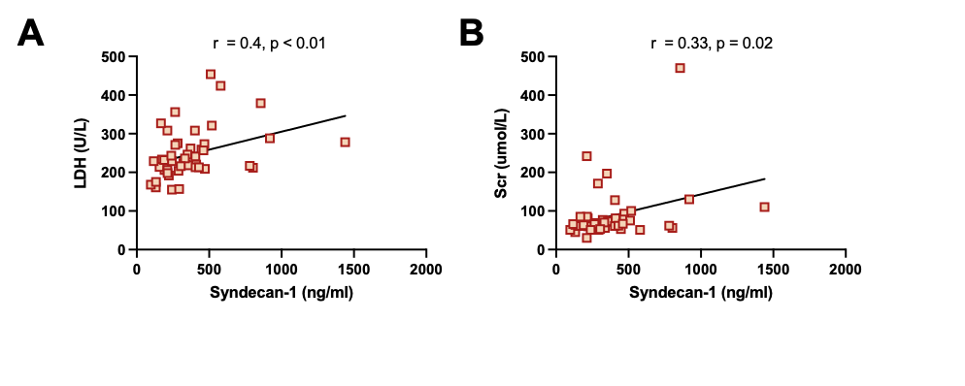
Supplementary Fig. 3. Plasma syndecan-1 levels and clinical parameters in patients with HBV-ACLF. (A) Correlation analysis of syndecan-1 with LDH. (B) Correlation analysis of syndecan-1 with Scr.

