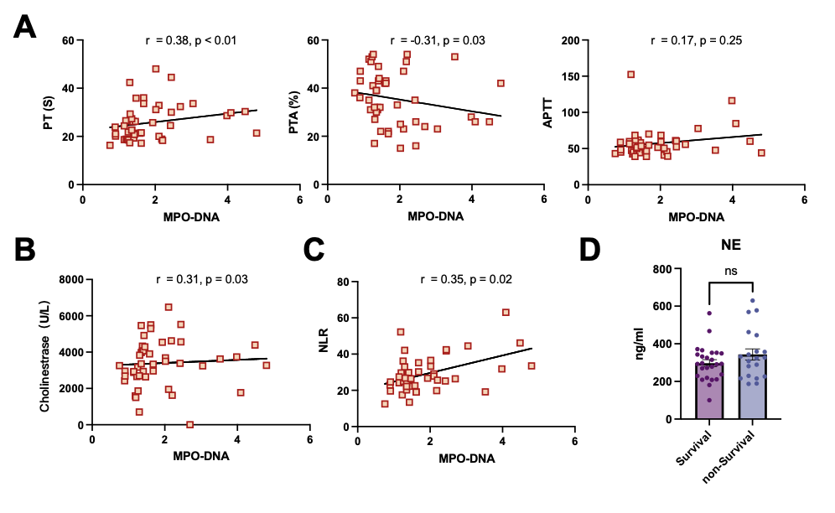
Supplementary Fig. 2. Plasma NETs markers and clinical parameters in patients with HBV-ACLF. (A) Correlation analysis of MPO-DNA with prothrombin time (PT), prothrombin activity (PTA), and activated partial thromboplastin time (APTT). (B) Correlation analysis of MPO-DNA with cholinesterase. (C) Correlation analysis of MPO-DNA with neutrophil-to-lymphocyte ratio (NLR). (F) Comparison of NE levels between survivors and non-survivors among HBV-ACLF patients.

