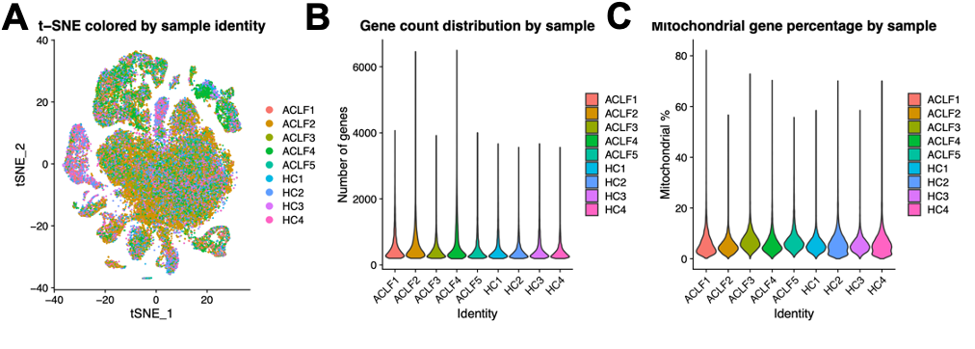
Supplementary Fig. 1. Quality Control and Sample Identity in Single-Cell RNA Sequencing Analysis. (A) t-SNE plot showing the distribution of all cells colored by sample identity, including five HBV-ACLF samples (ACLF1–ACLF5) and four healthy control samples (HC1–HC4). (B) Violin plot showing the distribution of detected gene numbers (nFeature_RNA) across individual samples. (C) Violin plot showing the distribution of mitochondrial gene percentages (percent.mt) across samples.

