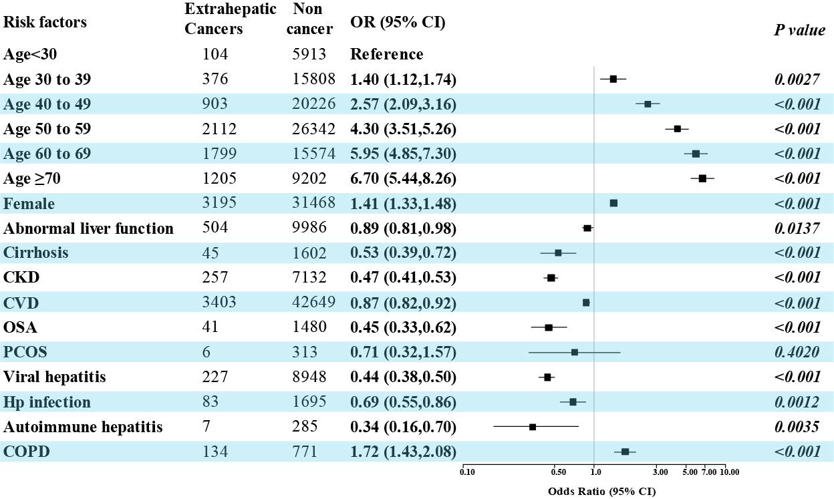
Supplementary Figure 4. The association of comorbidities and extrahepatic cancers in the MASLD population. CKD, Chronic kidney disease, OSA, Obstructive Sleep Apnea, PCOS, Polycystic Ovarian Syndrome, COPD, Chronic obstructive pulmonary disease.

