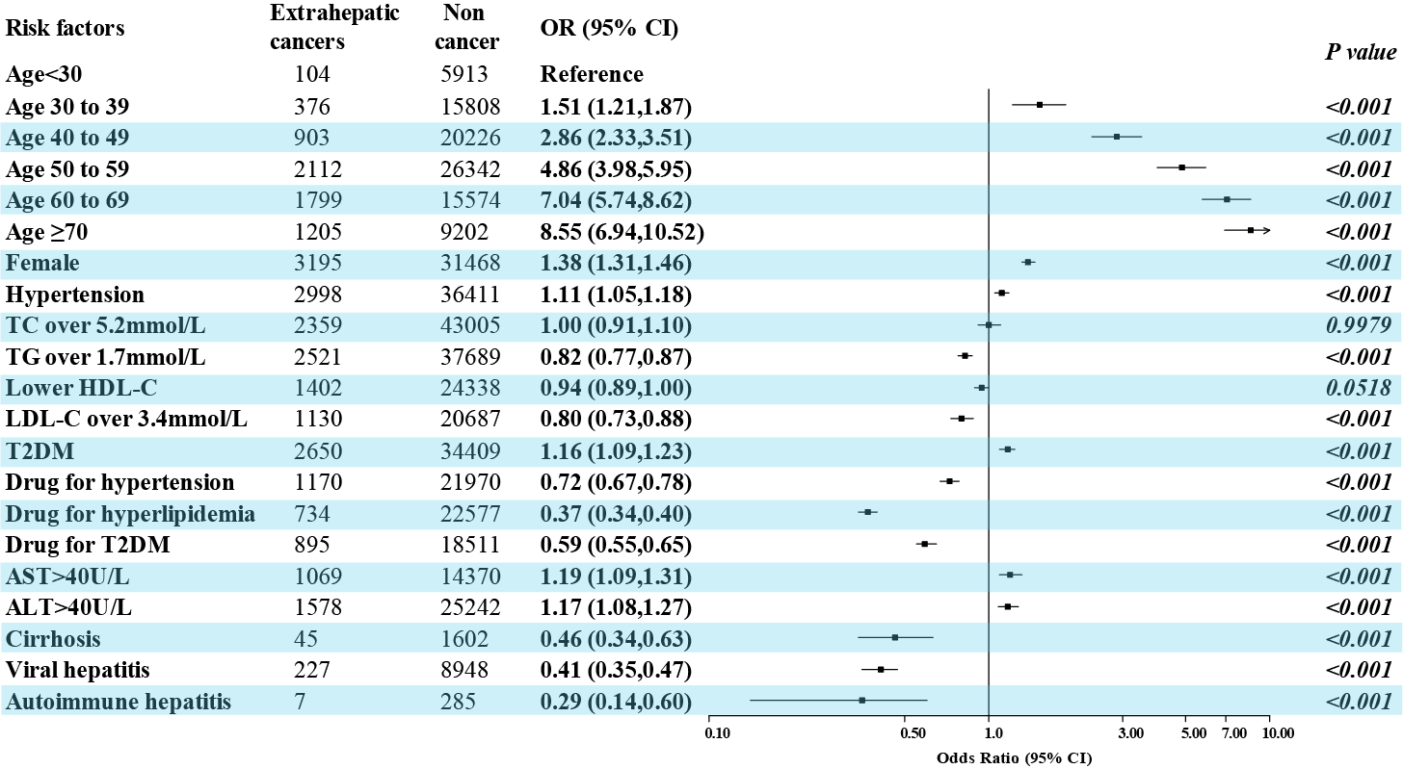
Supplementary Figure 3. The association of diagnosed specific dyslipidemia, elevated liver enzyme, pharmacological treatments of the metabolic dysfunction, comorbidities and extrahepatic cancers in the MASLD population. ALT: Alanine Aminotransferase; AST: Aspartate Aminotransferase; T2DM: type 2 diabetes mellitus; TC: Total cholesterol; TG: Triglyceride.

