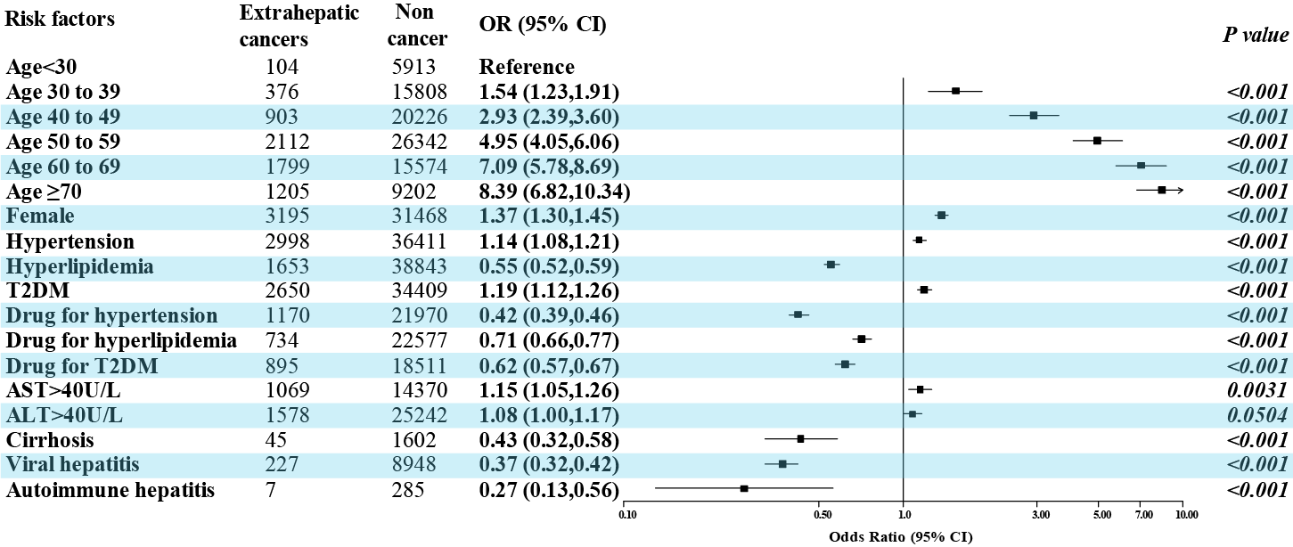
Supplementary Figure 2. The association of diagnosed specific metabolic dysfunction, elevated liver enzyme, pharmacological treatments of the metabolic dysfunction, comorbidities and extrahepatic cancers in the MASLD population. ALT: Alanine Aminotransferase; AST: Aspartate Aminotransferase;T2DM: type 2 diabetes mellitus

