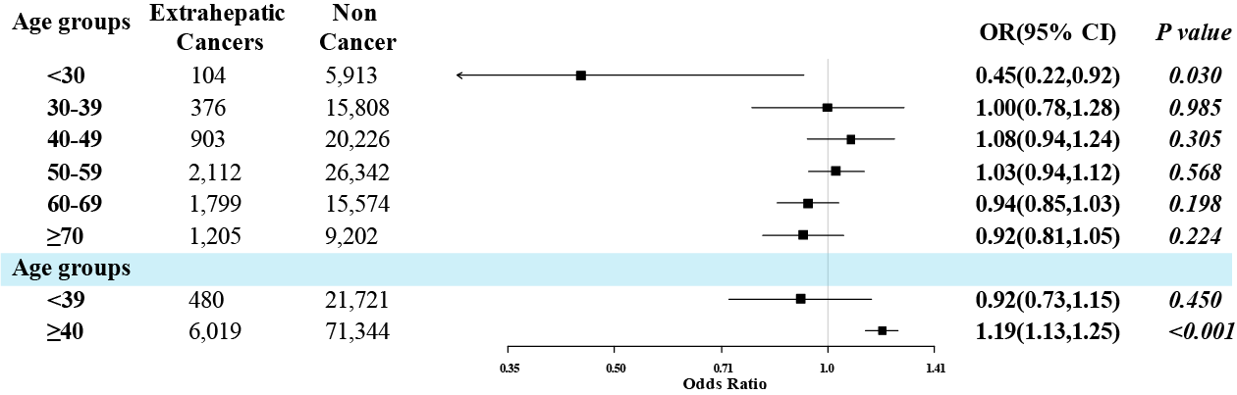
Supplementary Figure 1. The association of hypertension and extrahepatic cancers in age stratification subgroups analysis.

