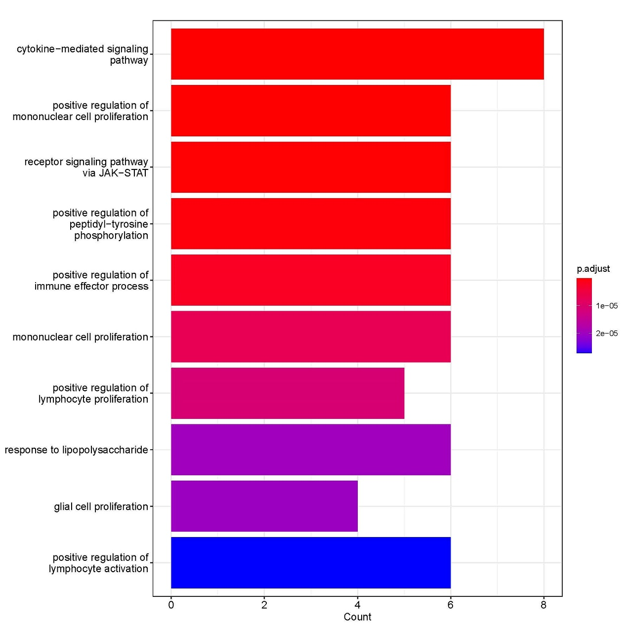
Supplementary Fig. 3. Gene ontology functional enrichment analysis of cytokines present at significantly different levels between the survival and the death-or-liver transplantation groups.

