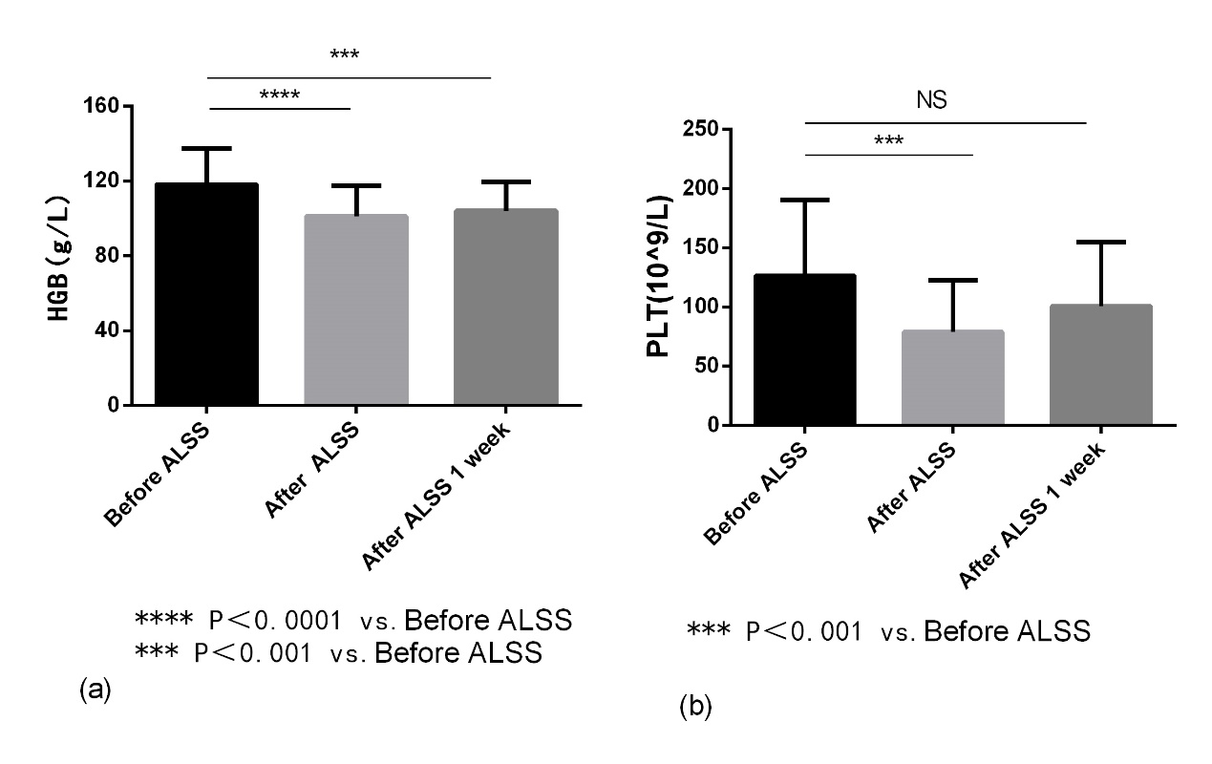
Supplementary Fig. 2. Changes of the levels of HGB and PLT after DPMAS+LPE treatment. (a) HGB; (b) PLT. HGB, hemoglobin; PLT, platelet; ALSS, artificial liver support system.

