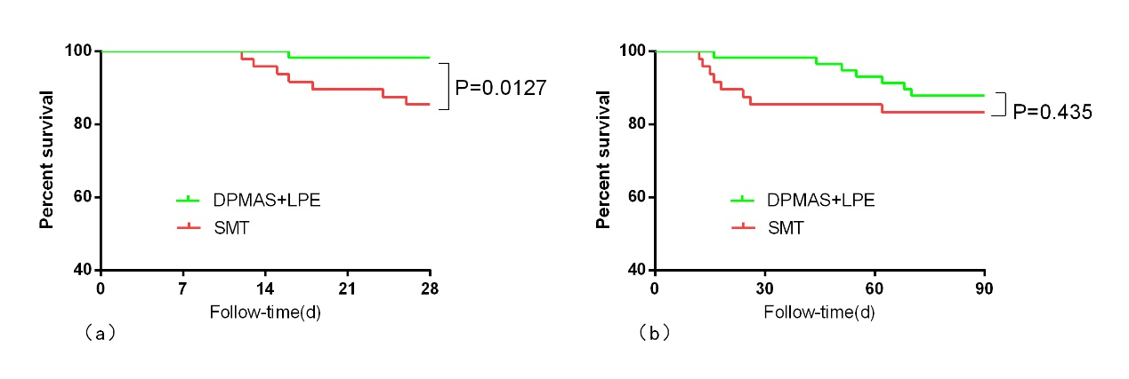
Supplementary Fig. 1. The Kaplan-Meier survival curves between SMT group and DPMAS+LPE group in the entire cohort. (a)At 4-week; (b) At 12-week. DPMAS+LPE, double plasma molecular adsorption system with sequential low-dose plasma exchange; SMT, standard medical treatment.

