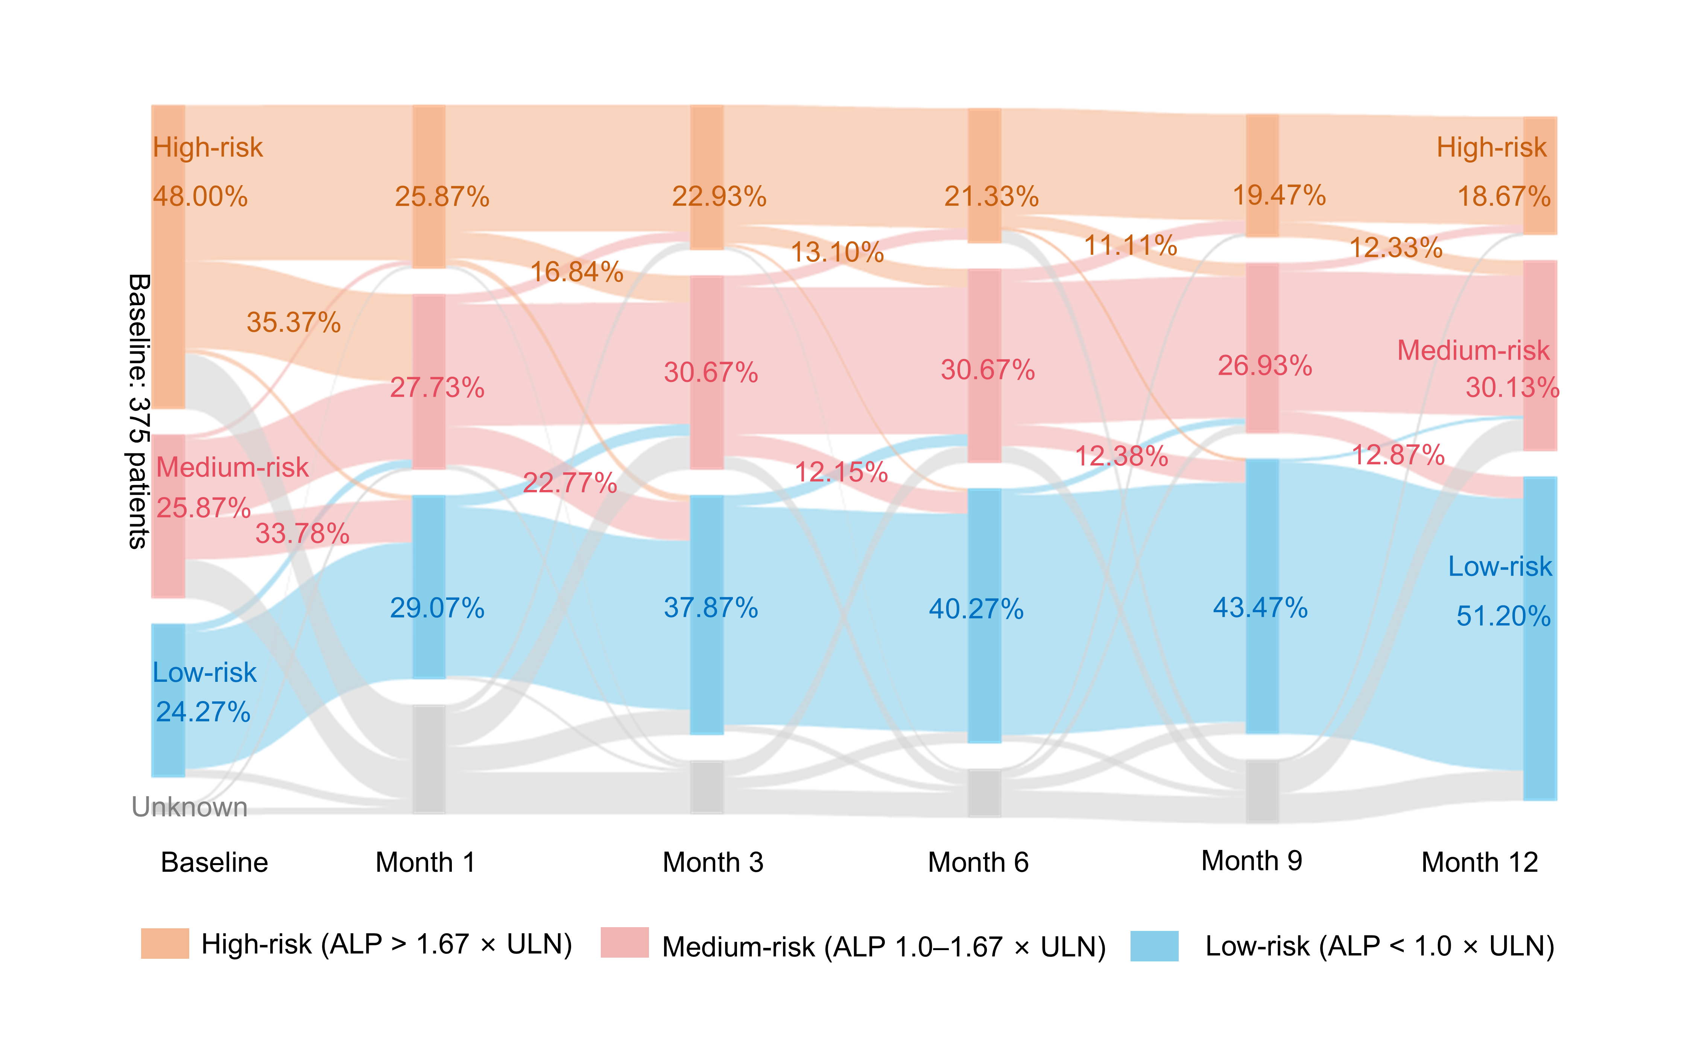
Supplementary Figure 2 Analysis of the dynamic migration path of risk levels within one year (Pre-Imputation Data).
The Sankey diagram depicts the transitions between risk categories over 12 months for 318 PBC patients, who underwent six follow-up assessments (baseline and at 1, 3, 6, 9, and 12 months). The width of the arrows corresponds to the number of patients, and the labels indicate absolute counts (N) and percentages (%), relative to the total population of the preceding node. The risk categories are defined as follows: high risk (orange, ALP >1.67×ULN), medium risk (pink, ALP 1.0–1.67×ULN), low risk (blue, ALP <1.0×ULN) and gray indicates patients for whom follow-up records are missing this time. Minor transitions (<5% of total flow) were aggregated as "other pathways" and omitted from the labels. Abbreviations: ALP: alkaline phosphatase; ULN: upper limit of normal.

