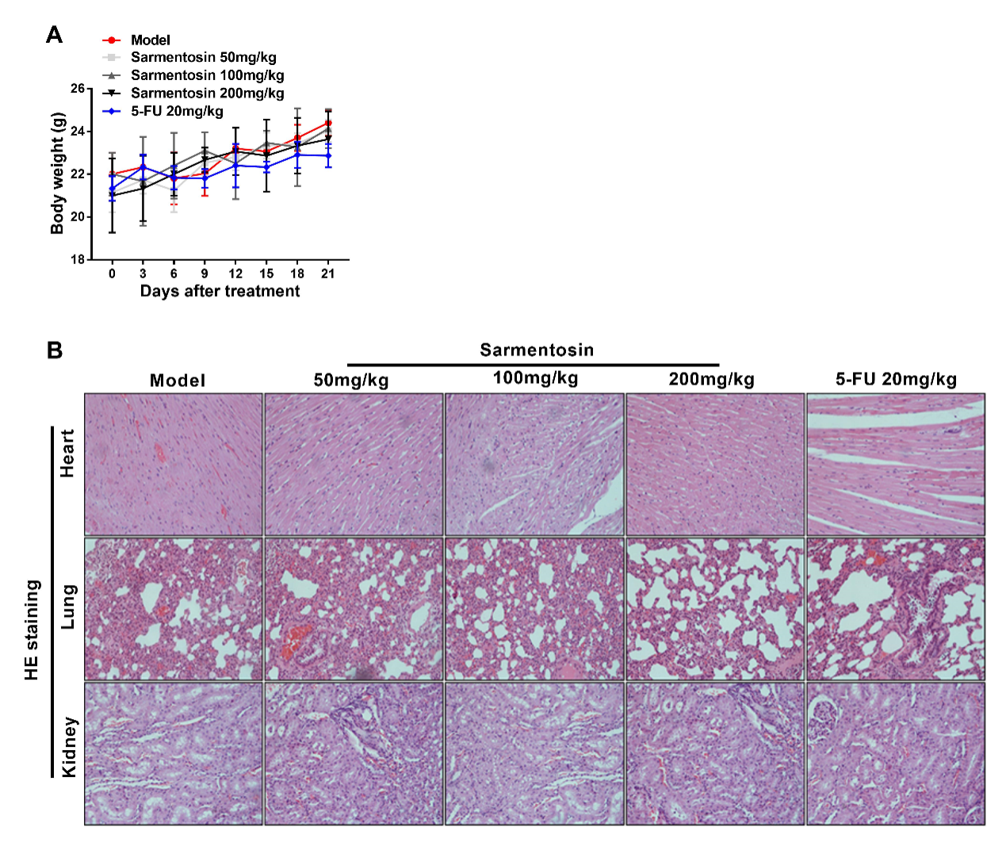
Supplementary Fig. 2. Sarmentosin was not toxic to nontumor tissues in xenograft nude mice. (A) Weight was measured every 3 days in xenograft nude mice that treated with or without different concentrations of sarmentosin (50, 100, 200 mg/kg) or 5-FU (20 mg/kg) for 21 days. n = 6. (B) Representative images of hematoxylin and eosin staining of heart, lungs and kidney sections from xenograft nude mice treated with or without different concentrations of sarmentosin (50, 100, 200 mg/kg) or 5-FU (20 mg/kg) for 21 days. n = 6.

