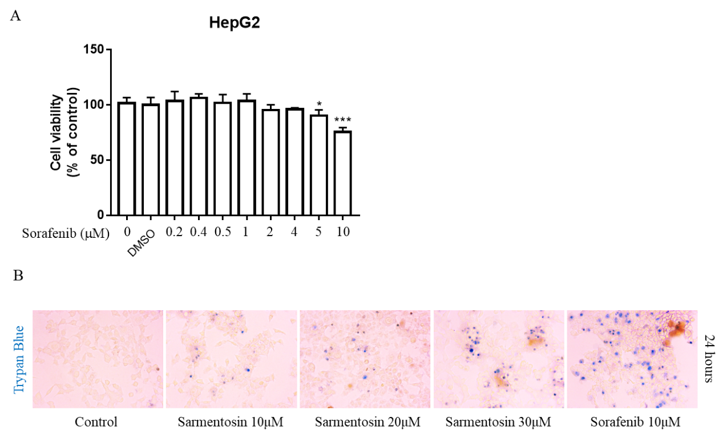
Supplementary Fig. 1. Sarmentosin and sorafenib were effective in HepG2 cells. (A) HepG2 cells were treated with DMSO (0.02%, w/v), or sorafenib (diluted in DMSO) at different concentrations for 24 h to determine the best dosage of sorafenib in vitro. Cell viability was determined with a CCK-8 assay. Data are percentage of control value (n = 6). *p < 0.05, **p < 0.01, ***p < 0.005 vs. control group. (B) The indicated dosage of sarmentosin and sorafenib were applied to HepG2. Cell mortality was assessed by trypan blue staining (n = 3). Cells marked in blue are dead.

