Supplementary figure
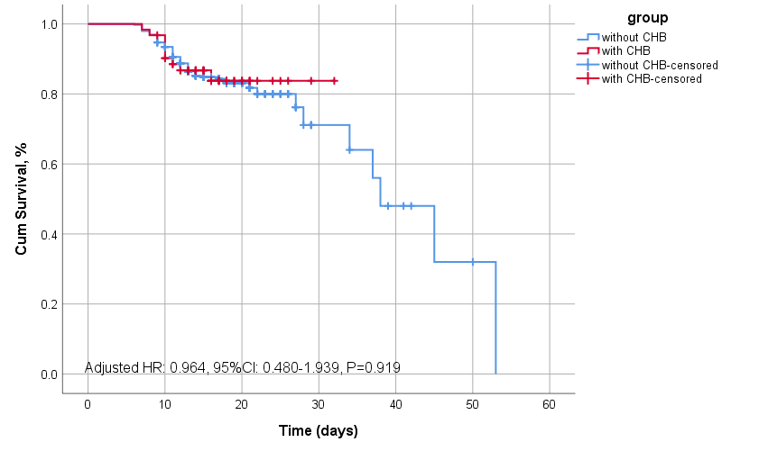
Supplementary Figure 1. Kaplan-Meier survival curve for mortality of SFTS patients with hepatitis B and without hepatitis B after adjustment. Days after disease onset are on the abscissa, and survival is on the ordinate. Multivariate Cox regression was adjusted for sex and age. CI, confidence interval; HR, hazard ratio.

