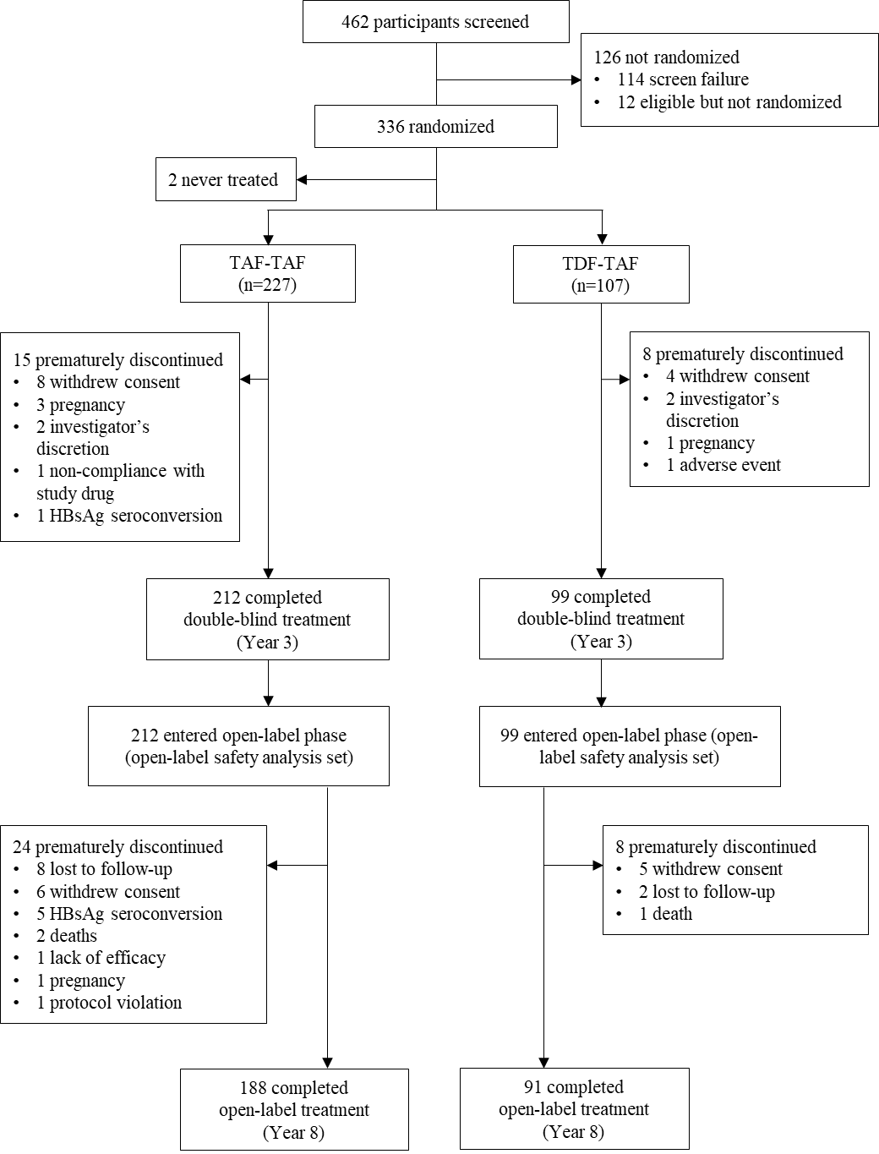
Supplementary Fig. 1. Participant disposition.
HBsAg, hepatitis B surface antigen; TAF, tenofovir alafenamide; TDF, tenofovir disoproxil fumarate.

