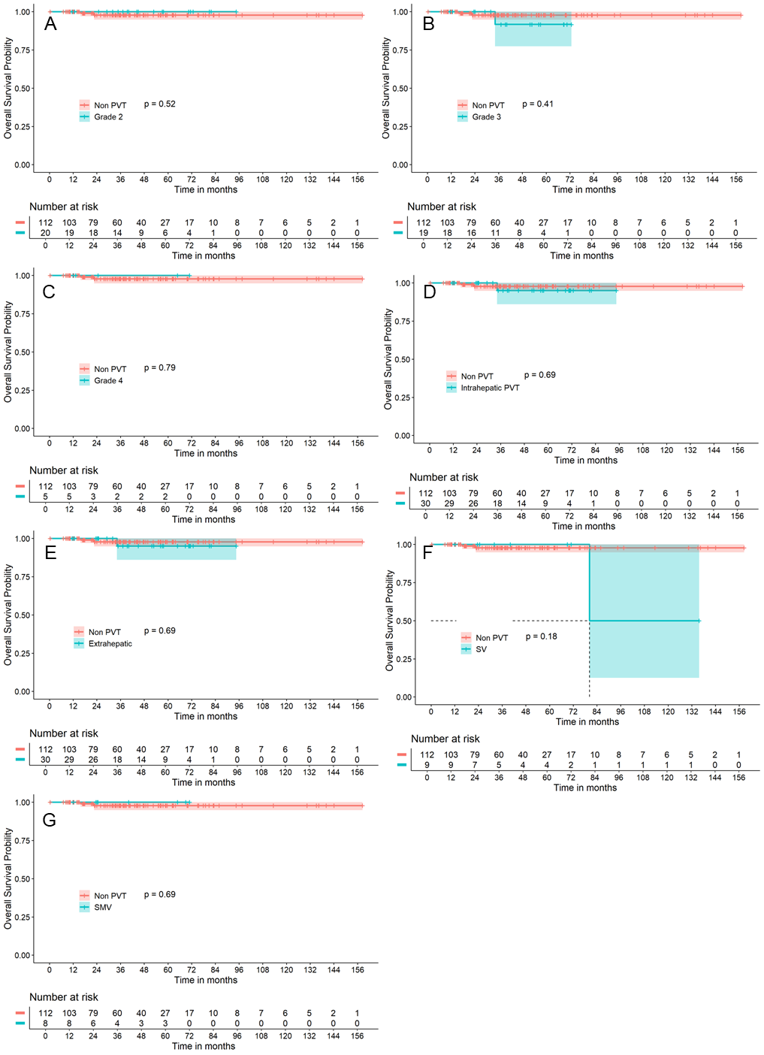

**Supplementary Fig. 1. Kaplan–Meier curves of liver-transplantation-free survival in PSVD patients with and without PVT subtypes.** Kaplan–Meier survival curves comparing liver-transplantation-free survival between patients without PVT (red) and those with different locations or grades of PVT (blue). PSVD, porto-sinusoidal vascular disease; PVT, portal vein thrombosis.