Supplemental Table 1. Focused solid tumor assay gene list

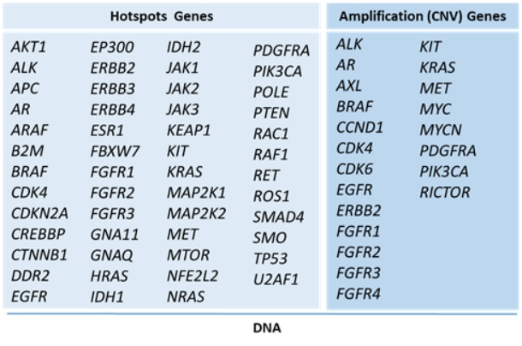

CNV, copy number variation.