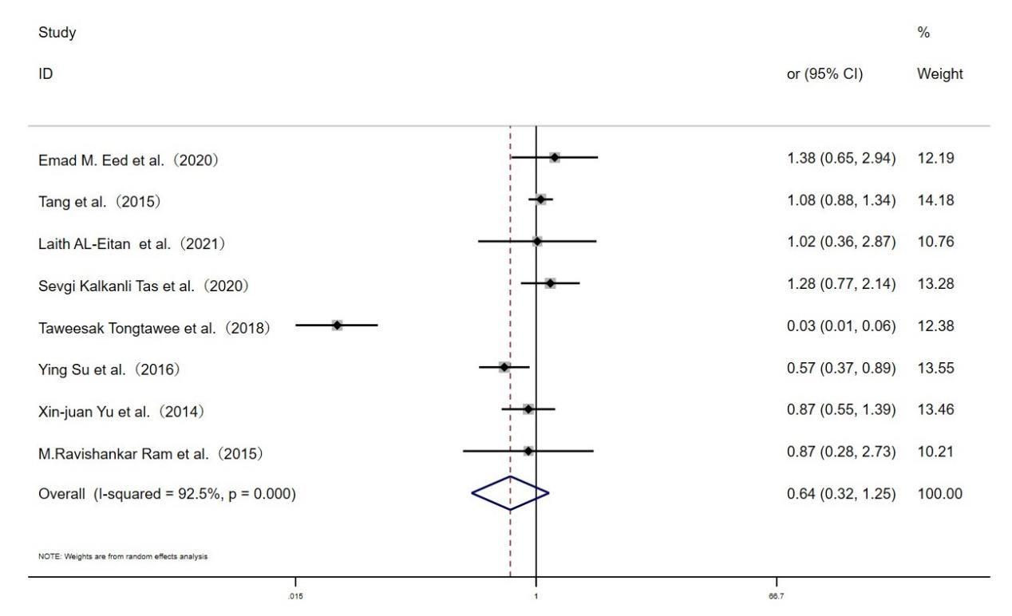

**Fig. S4 Forest plot for the associations between TLR10 rs10004195 polymorphism and *H.pylori* infection risk through heterozygous model (AT vs.TT)**