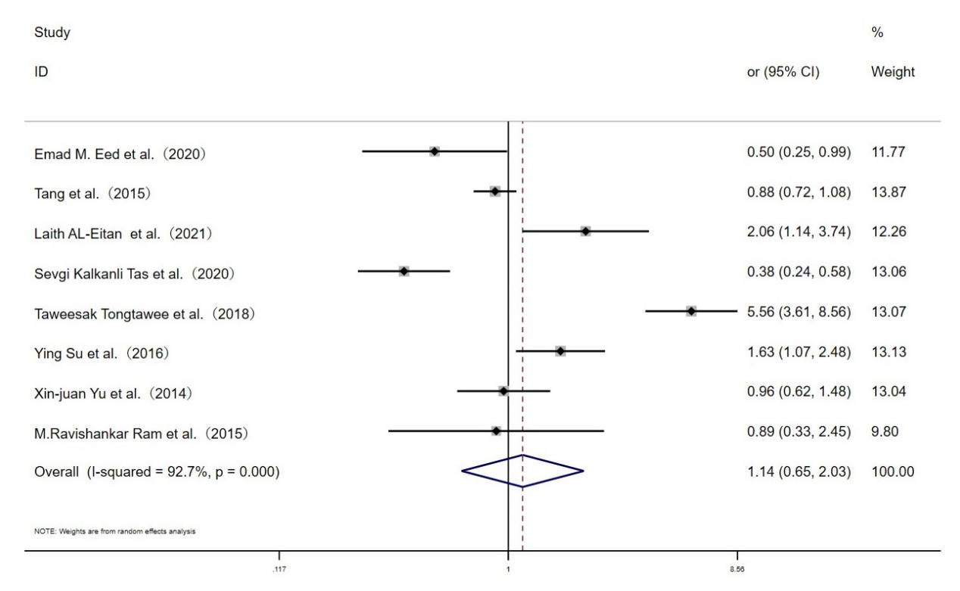

**Fig. S3 Forest plot for the associations between TLR10 rs10004195 polymorphism and *H.pylori* infection risk through dominant genetic model (TT vs.AT+AA)**