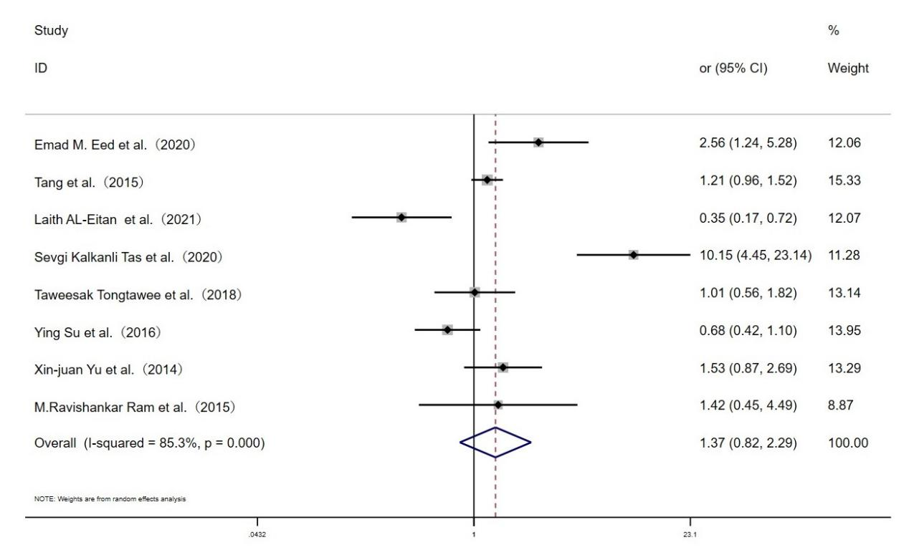

**Fig. S2 Forest plot for the associations between TLR10 rs10004195 polymorphism and *H.pylori* infection risk through homozygous model (AA vs.TT)**