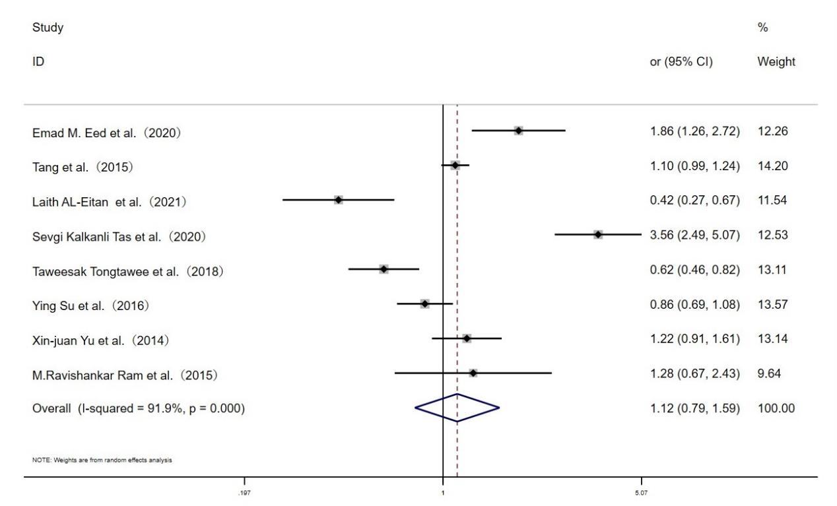**Fig. S1 Forest plot for the associations between TLR10 rs10004195 polymorphism and *H.pylori* infection risk through allelic model (A vs.T)**