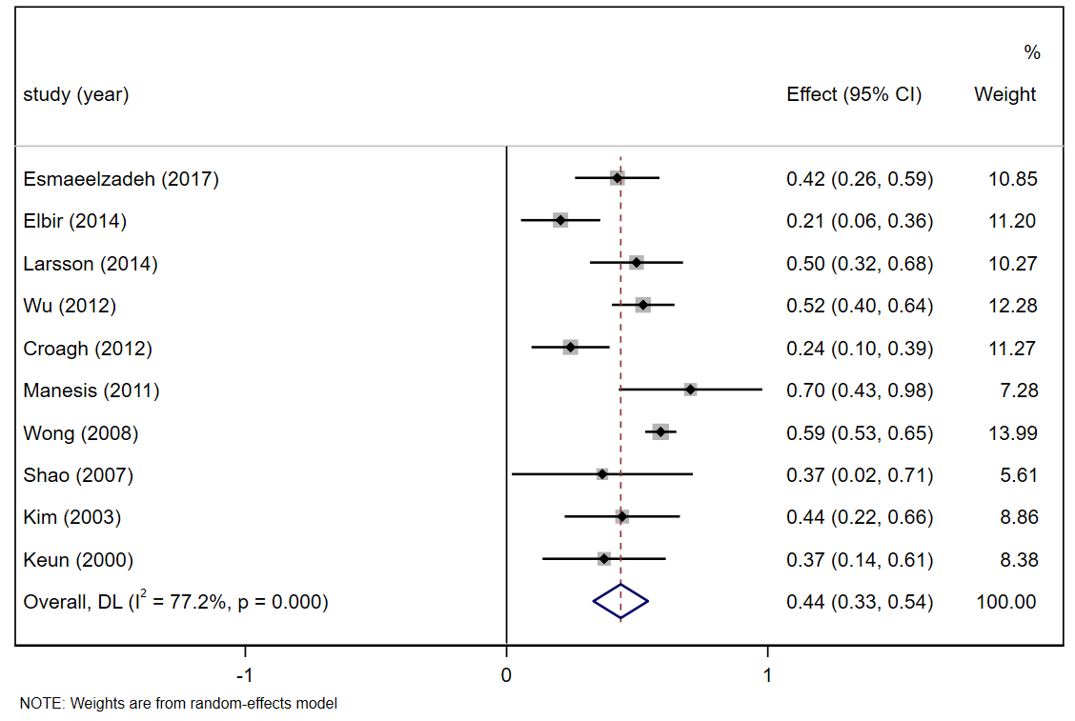
Figure S3. Forrest plots for the relationship between HBV DNA and ALT in different studies of patients with HBeAg negative.
Notes: After excluded four studies (Schwarz 2019; Hou 2013; Ijaz 2011; Sangfelt 2004), I² decreased to 77.2%, overall R value was 0.411(95%CI: 0.321-0.494).

